Press Contacts:
Krysten Koval, Director of Marketing
972-348-2367
Krysten_Koval@texanscu.org

Kristine Tanzillo, Dux Public Relations
903-865-1078
kristine@duxpr.com

Veterans Center of North Texas Receives $3,500
from Employees of Texans Credit Union

Richardson, Texas (December 16, 2021) – Honoring local veterans, employees of Texans Credit Union have donated $3,500 to the Veterans Center of North Texas.

The non-profit Veterans Center of North Texas is an all-volunteer organization that helps veterans and their families connect with qualified service providers based on their individual needs. Whether it is employment services, housing, or financial, legal, or medical assistance, the organization helps veterans ensure they receive all eligible benefits. The organization also provides short-term assistance to help veterans overcome temporary personal crises.

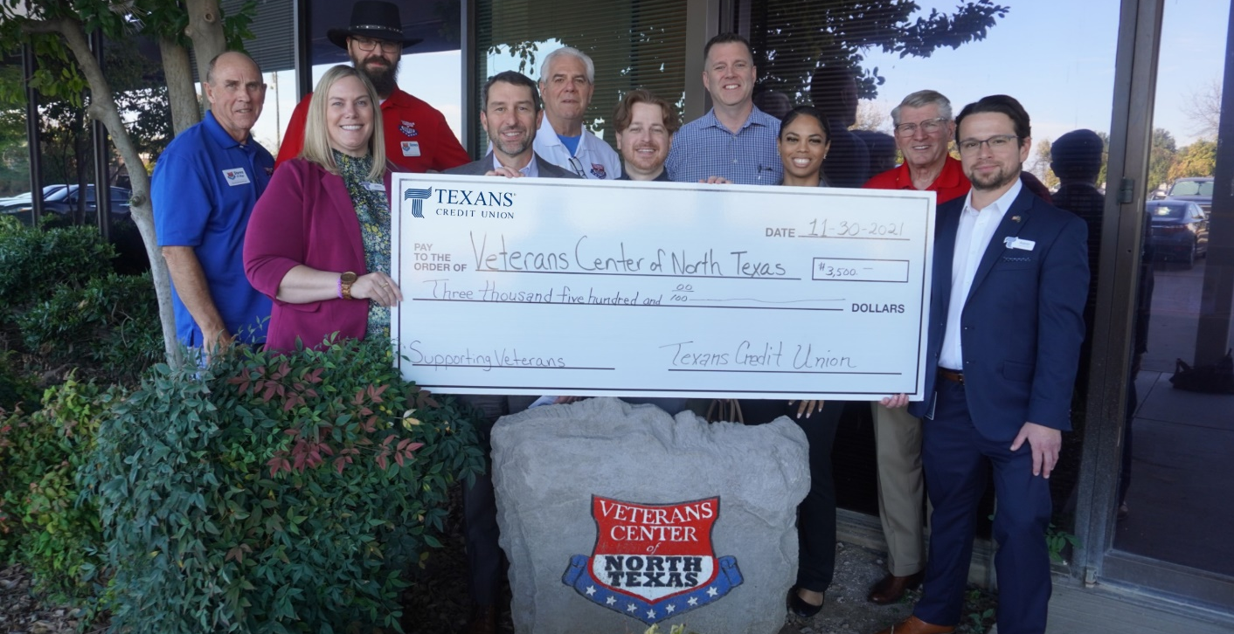

Texans employees were inspired by the many veterans they have has employees, members, and family members. They generated a special week-long internal fundraising effort for the Veterans Center.

“As Americans, we are all indebted to our veterans, young and old, for the sacrifices they have made and continue to make to serve our country,” said David Frazier, president of Texans Credit Union. “This donation is a small gesture of our employees’ gratitude for everyone who has served.”

About Texans Credit Union
Texans Credit Union is a full-service, not-for-profit financial institution that serves more than 110,000 members throughout the DFW area. With more than $2 billion in assets, Texans Credit Union is one of the largest member-owned financial institutions in the DFW area, serving its members and the community since 1953.

###

Photo Caption: Four Texans CU employees who are also Veterans visited the Veterans Center of North Texas to help present a donation of $3,500. The Veterans from Texans pictured are Mark McKinley (back row, 4th from left) and Geoff Shields (front row, center), Lauren White (front row, 4th from left), and Aaron Martinez (front row, far right).

