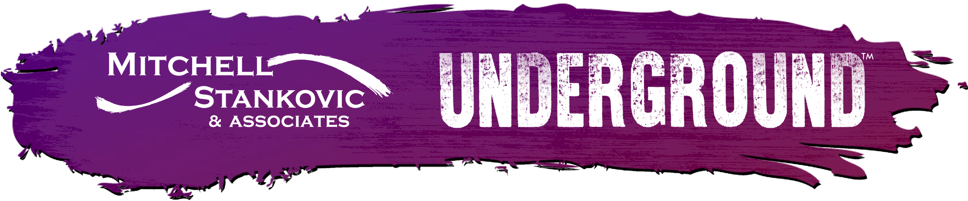

Contact
Zach Christensen
602.390.7655
zach@mitchellstankovic.com
2020, A Year in the Underground
Underground Collision memorializes a year of disruption, unrest and vulnerable collaboration. Check out the power of the Underground voice here.

The Underground, founded by Mitchell, Stankovic & Associates, kicked off 2020 with the Underground Collision RAW in Washington DC discussing the vulnerability of our members and recognizing their life stages through Maslow’s Hierarchy. Little did we know that weeks later the world would be forever changed.
2020 became the year of incredible disruption! We were all stunned and overwhelmed by the sheer magnitude of the issues we faced individually when a communal voice started to rise, WE ARE STRONGER TOGETHER. Our new reality brought forth the undeniable strength, power and will of the people within the credit union system. Underground thought leaders became stronger, bolder in using their voices responding to unprecedented shifts in society. From Maslow’s Hierarchy to explosive Social Unrest, Fractured Lives to Warp Speed Technology, Activate Your Next to I AM A CREDIT UNION, the Underground community stood up and stepped in on important issues that ARE affecting the people, our members.
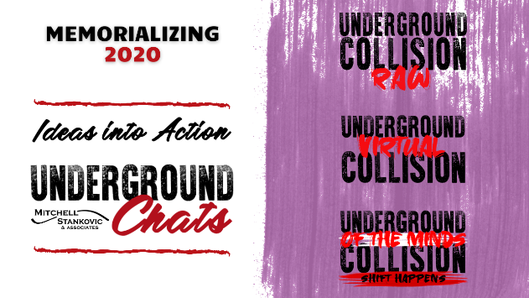
During this exploration of uncharted territories, the Underground pivoted to create the first Underground Virtual Collision in July and then in October, the Underground Collision of the Minds: Shift Happens. Thousands engaged virtually to hear an emergence of fresh perspectives. The Underground brought together more than 70 speakers/thought leaders worldwide who are adapting to change, leading the charge, speaking out and standing up for what was right.
In honor of one of the most challenging years to affect billions around the world, we have memorialized the Underground movement in 2020. The collisions, the chats, the whitepapers and the thought leadership that proved credit unions could, and would, be an industry that put community first.
Join us in 2021 as we kick off 2021 with the Underground Collision BFO – Blinding Flash of the Obvious on March 1, 2021 from 9:00 am to 11:00 am PST. Register here!

# # #

The Underground Community, founded by Susan Mitchell of Mitchell, Stankovic & Associates, is an authentic voice of the credit union movement facilitated by industry thought leaders. We drive change, encourage diverse opinions, and force off-record discussions to become on-record initiatives. The hundreds of Underground Colliders believe through incremental, grassroots change, credit unions can put ideas into action and revolutionize core cooperative principles: people helping a diverse world of people come together for a better life, individually and communally. Check Out More Underground Resources
Mitchell, Stankovic & Associates is a is a strategic consulting firm specializing in the credit union industry to increase consumer impact, market relevance and modernize business practices from board governance to CEO and leadership transitions. We are trusted advisers and industry thought leaders who believe that making a difference is our highest priority demonstrated by our long-term relationships and stellar reputation.

