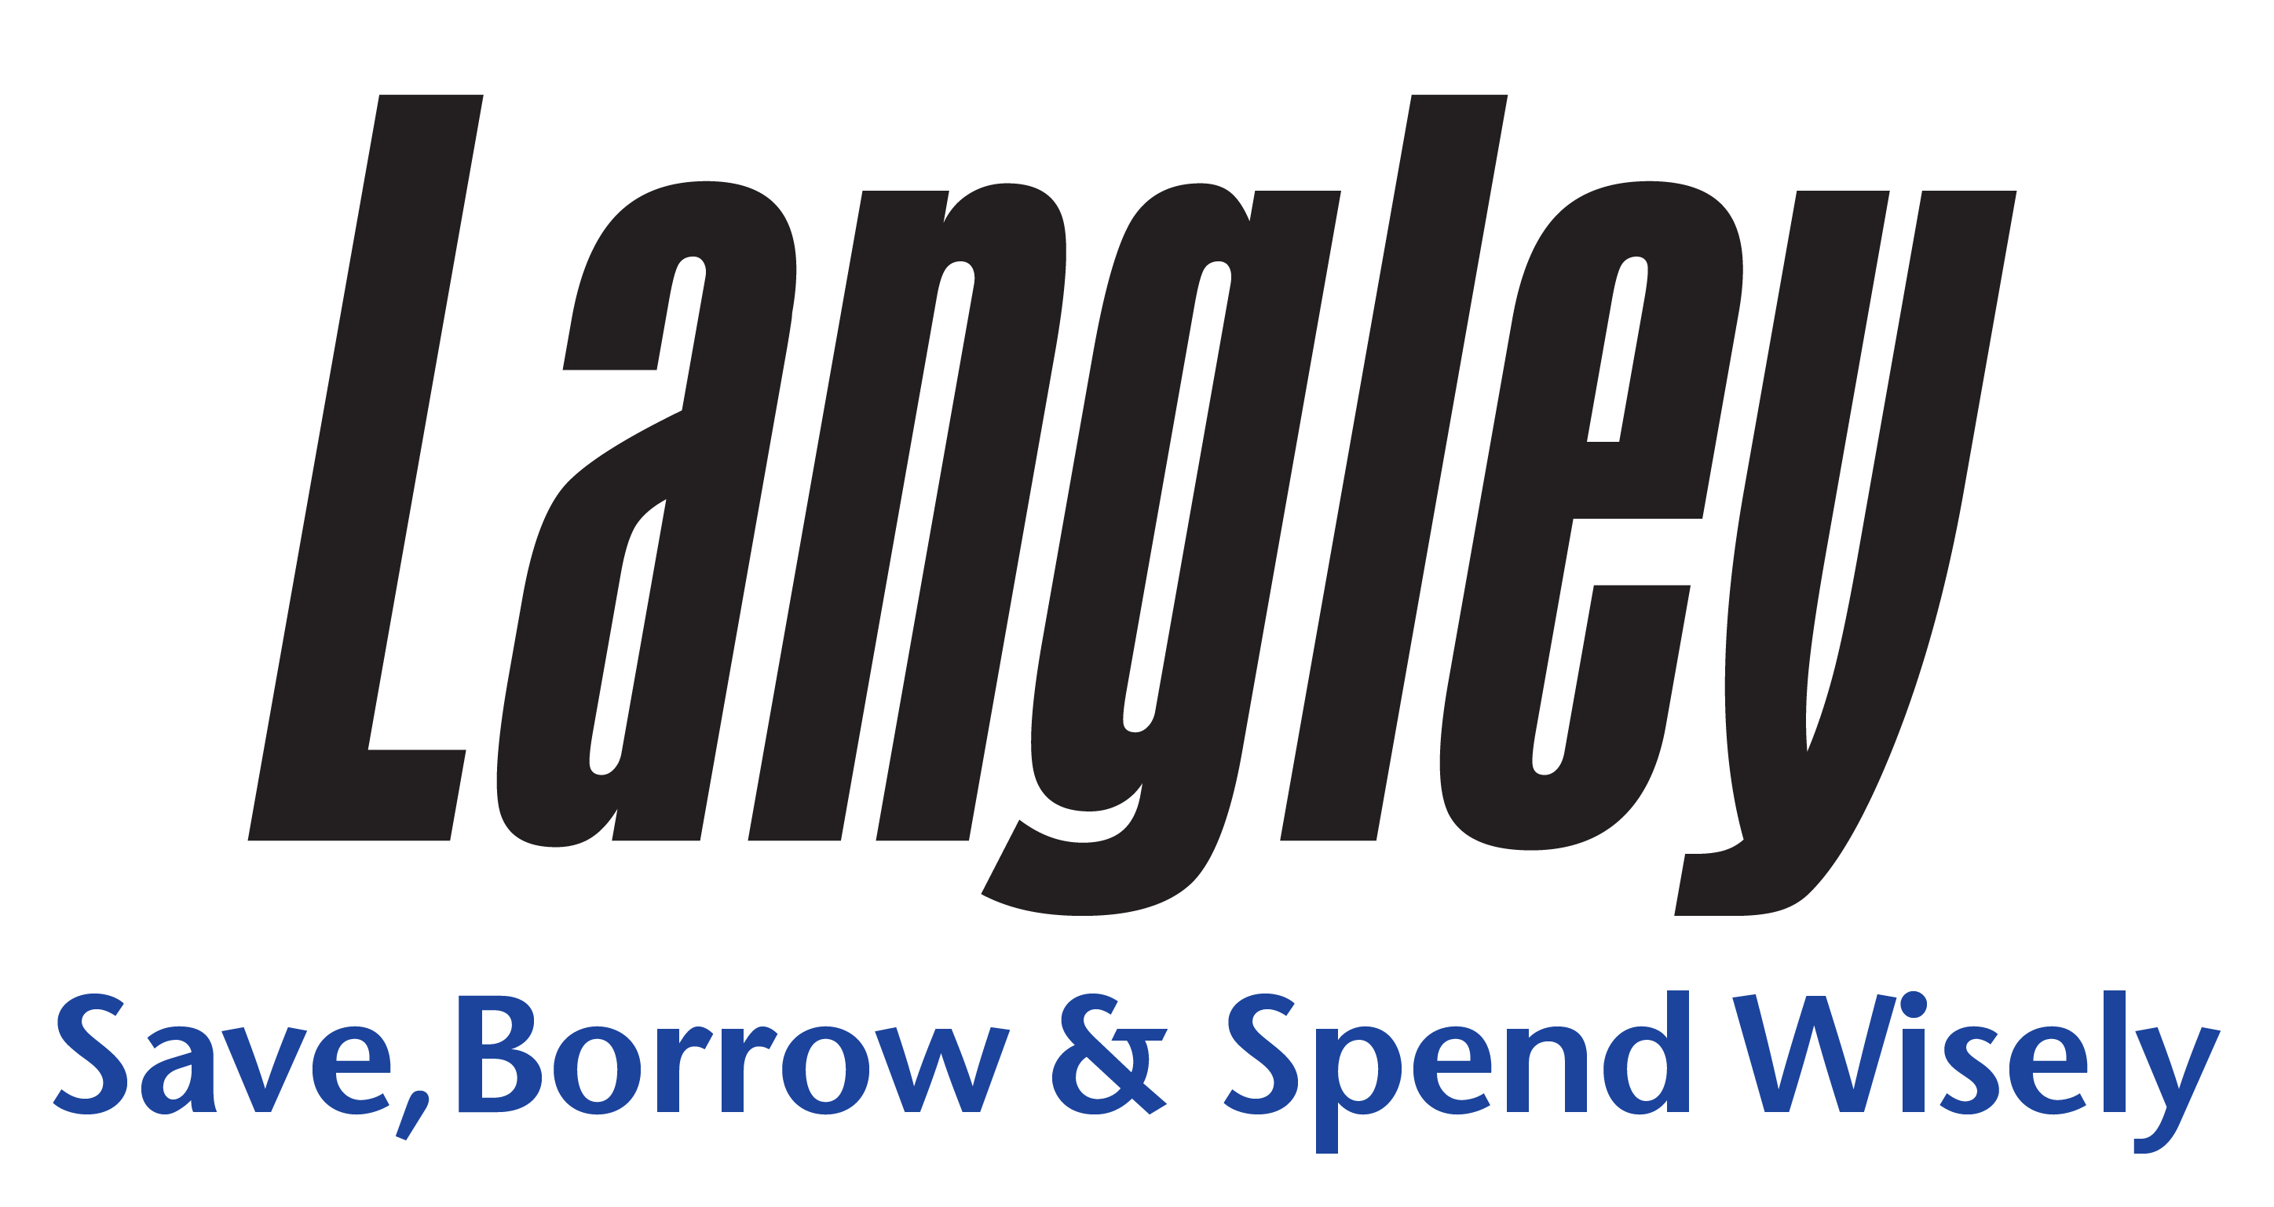

FOR IMMEDIATE RELEASE: October 20, 2021

Media Contact: Fred Hagerman, Chief Marketing Officer, Langley FCU
Phone: 757-643-8741
Email: fhagerman@langleyfcu.org
Virginia Beach Schools Federal Credit Union and Langley Federal Credit Union
Announce Merger Approvals
Combined, the organization will serve more than 310,000 members, with 21 branches and assets over $4.1 billion dollars.

Newport News, VA – Virginia Beach Schools Federal Credit Union and Langley Federal Credit Union have announced their merger has received regulatory approval as well as approval by majority vote of the VBSFCU membership. The legal merger date for the two organizations is planned for November 1, 2021. At the time of the legal merger date VBSFCU and Langley will begin to operate as one legal entity. From a member perspective, it will be “business as usual” for VBSFCU members. Both organizations will continue to serve their members at their individual branch locations as they ramp up efforts to have VBSFCU systems fully integrated with Langley by April 1, 2022.

The merger between these credit unions will bring greater value, and provide more access to their combined members, employees, and the communities they serve. VBSFCU and Langley share similar values, a member-first philosophy, believe passionately in helping members save, borrow, and spend wisely, and are committed to making a difference in the communities they serve.
Tom Ryan, CEO of Langley will be the CEO of the combined organization. Brian Clark, CEO of VBSFCU will hold a leadership role in the combined organization.
Tom Ryan, shared, “At every turn during this partnership, we’ve continued to see similarities in our philosophies and our Vision. Both of our organizations are passionate about serving members.” Ryan goes onto say, “Langley Federal is honored that Virginia Beach Schools Federal Credit Union’s board of directors and leadership team put their trust in us and chose us as a merger partner. Together, we’re going to continue to do great things.”
Brian Clark, added, “I want to thank our VBSFCU board members, members, and team members alike for their active participation in the voting process and for their commitment and loyalty to help ensure our ongoing growth and success.”
As the merger process continues, both credit unions will provide ongoing merger information via their websites (www.vbsfcu.org and www.langleyfcu.org) and other applicable communication channels.
Langley Federal Credit Union
Langley Federal Credit Union is a federally-chartered credit union, regulated and insured by the National Credit Union Administration. Langley Federal Credit Union serves more than 300,000 members and has $4 billion in assets, ranking the financial cooperative as one of the 100 largest credit unions in the country. Langley is a full-service financial institution where everyone can save, borrow, and spend wisely. Located in Hampton Roads, Langley has 20 branches, over 600 employees and more than 55,000 surcharge-free ATMs throughout the region. For more information, visit www.langleyfcu.org.
Virginia Beach Schools Federal Credit Union
Virginia Beach Schools Federal Credit Union was chartered in 1960. VBSFCU has more than $115 million in assets, serving more than 7,000 members. Since its inception, VBSFCU has grown to be the premier credit union for all Virginia Beach City Public Schools, Accomack and Northampton County Schools, and Virginia Wesleyan University. In addition, they serve employees of the Virginia Beach Adult Learning Center, St. John the Apostle Catholic School, and the Art Institute of Virginia Beach.
###

