Texas Trust Credit Union Breaks Ground
for New Branch in Grand Prairie

Arlington, Texas – February 4, 2021 – Texas Trust Credit Union will soon have a new branch at South Carrier Parkway and I-20 in Grand Prairie, which is seeing significant expansion of retail and restaurant development. The credit union broke ground today on a new 4,280-square-foot building near Fish Creek Preserve.

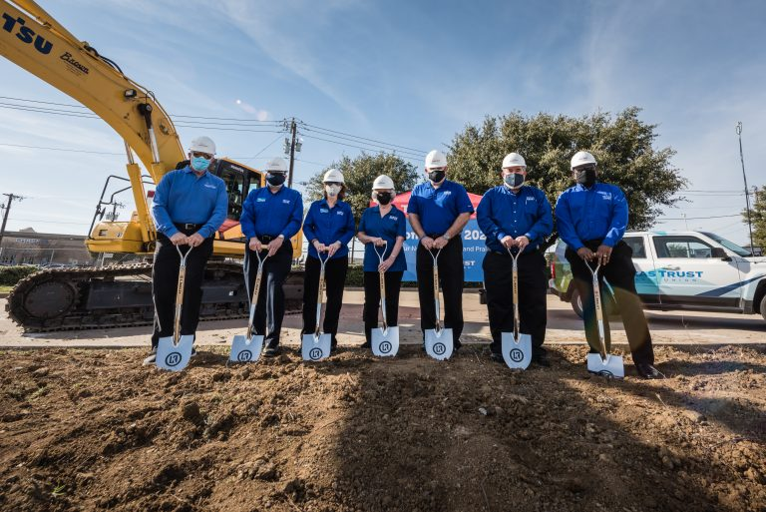
The new full-service branch will also serve as a community hub, with a community room, partner office, and a unique convertible outdoor space for small events. There will be three drive-thru lanes so members don’t have to leave their vehicles to conduct routine transactions. The branch will also offer checking and deposit services, mortgages for new homes or refinancing, loans for cars and recreational vehicles, low-interest credit cards, and more.

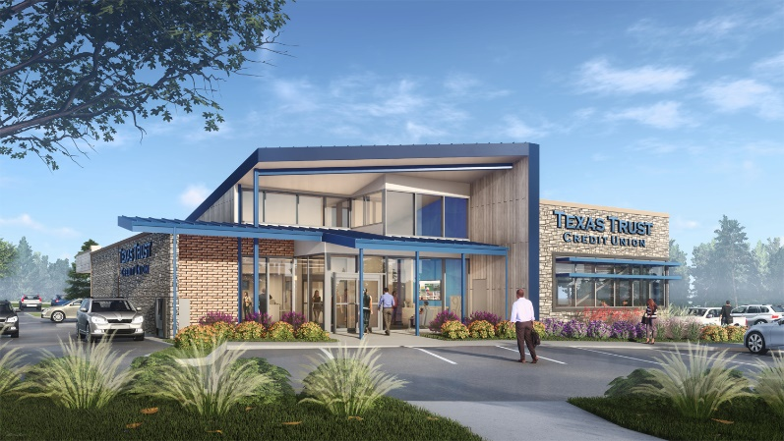
The building will be a modern structure with exterior facades in limestone, adobe brick, and weathered wood accents highlighted with a sweeping volume of “Texas Trust Blue” metal and glass, which will glow with blue light during the night. The interior will feature clean, bright, and polished aesthetics warmed with wood accents.

L. Keeley Construction of St. Louis worked with Oculus, Inc., on the design and will oversee the building project.

This will be Texas Trust’s third branch in Grand Prairie and 20th in the state. The branch opening is scheduled for late 2021.

“We have been part of the Grand Prairie community since 1948. We are excited to see all the recent growth and to be part of its expansion,” said Jim Minge, CEO of Texas Trust Credit Union. “Our goal is to continue to help our members in Grand Prairie have convenient access to financial services that will help them build brighter financial futures.”

Building renderings and high resolution images of the groundbreaking ceremony can be downloaded here.

About L. Keeley Construction
L. Keeley was founded in 1976 as a family-owned paving company. Over four decades and 850+ Keeley’ns later, L. Keeley has become a nationally-known, full-service construction company with four diverse business groups – Civil, Paving, Building, and Industrial. L. Keeley Building is nationally recognized for its impact on communities, positively changing the way people shop, work, learn, engage, and evolve. L. Keeley Building’s expertise allows them to accommodate a wide variety of projects, with a customer-centric nature that is redefining how modern construction ventures and planned and executed.

About Texas Trust Credit Union
Texas Trust Credit Union has been helping build brighter financial futures since its modest beginning in 1936. Today, the full-service credit union serves more than 120,000 members. With assets of more than $1.5 billion, Texas Trust is the 5th largest credit union in North Texas and the 16th largest in Texas. With a focus on the community, Texas Trust is creating a legacy of giving through generous financial donations that support local school programs and activities, non-profit organizations, and student scholarships; and by providing volunteer resources through its Community Unity team, which supports scores of charitable events each year. For more information, visit TexasTrustCU.org or follow us on Facebook at facebook.com/texastrustcu or Twitter at @texastrustcu.

###

Photo Caption I: Photo by Hoang Nguyen – Life Stories by Hoang Photography. Pictured is the Executive Team of Texas Trust Credit Union breaking ground on its new branch in Grand Prairie at I-20 and S. Carrier Parkway.

Photo Caption II: Artist rendering of the new Texas Trust Credit Union Branch that will be located in Grand Prairie at I-20 and S. Carrier Parkway.

