Contact: Kristine Tanzillo, Dux Public Relations
kristine@duxpr.com / 903.865.1078

Dolphin Debit Now Offers Next Generation Branch
and ATM Locator Technology for Banks, Credit Unions
Wave2Locator integrates and simplifies location search to enhance the user experience
HOUSTON, April 6, 2021 – Dolphin Debit, the full-service ATM management company, now offers the next generation of ATM Locator technology via the Wave2 Locator.

This tool helps banks and credit unions simplify and enhance their location search and mapping functionality to promote all of their own branches and ATMs, retail locations, shared services, and multiple surcharge-free ATM networks, all in one cohesive user experience.

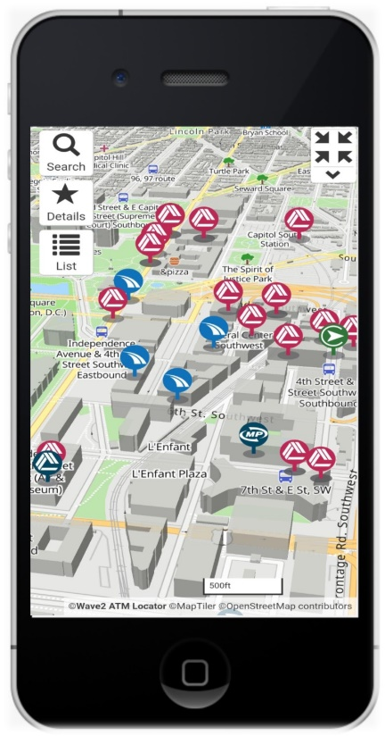
Rather than send users away from a trusted environment to third-party websites, the Wave2 Locator allows financial institutions to display a comprehensive presentation of branches, ATMs, surcharge-free ATM networks, and shared branches. The display shows live hours, features, restrictions, photos, street views, scheduling integration, and even Covid alerts – all within the bank’s or credit union’s own web and mobile platforms.

The Wave2 Locator, developed by Wave2, offers a mobile-responsive design that automatically adapts to the capabilities and screen size of each user’s device. It allows users the ability to view information in a traditional map or list format or from a birds-eye view or 3D perspective. It is fully ADA accessible and can be easily integrated with mobile apps and other systems.

With the Wave2 Locator, financial institutions can control all aspects of the location data and user interface in real time using powerful tools with simple drag-and-drop and push-button updating functionality that doesn’t require IT support. This simplifies updating of location details and hours, which is especially important when resources, hours, and restrictions are constantly changing. The tool also provides financial institutions deep insights into user search behavior and geographic interests, which can aid in decisions about new branch and ATM placements, retail partnerships, and geographically targeted marketing.

“We’re excited about offering this tool to our clients,” said Gary Walston, CEO of Dolphin Debit. “With the Wave2 Locator, banks and credit unions can bring all of their third party location data together into one platform, making it easier for them to manage and gain greater insight into users’ behavior and experience.”

Jason Green, Co-Founder of Wave2, noted that “The Wave2 Locator was designed to make it easier for financial institutions to promote all their convenient locations and access features from within their own trusted online environments. Additionally, the geographic interest data provides invaluable insight into how to best serve their customer and members.”

About Wave2
The Wave2 Branch & ATM Locator is an interactive location search and mapping tool for use inside the web and mobile offerings of credit unions, community banks, and other financial institutions. It allows users to find any of your own branch or ATM locations, your surcharge-free ATM network locations, and your shared branch locations, all in one tool without having to leave your trusted environment. Please visit www.wave2locator.com for more information and interactive demonstrations.

About Dolphin Debit
Dolphin Debit Access is a full-service ATM management company that owns and operates ATMs for financial institutions. Dolphin’s turnkey ATM service includes deployment of new ATM equipment combined with terminal driving, ATM maintenance, armored car service, communications, monitoring and dispatch, and cash management. Dolphin Debit operates all types of equipment in various on-premises and off-premises venues. In addition, Dolphin Debit has the rights to install and operate drive-up ATMs at Walmart/Murphy USA locations in multiple states. Dolphin Debit customizes solutions to the specific needs of clients, with a flexible, cost-saving approach that enables redeployment of company assets to improve the bottom line. For more information, visit dolphindebit.com.

###

