
Press Contacts:
Sidney Henderson, Texas Trust Credit Union
shenderson@TexasTrustCU.org
972-595-1259

Kristine Tanzillo, Dux Public Relations
kristine@duxpr.com
903-865-1078



AEG PRESENTS AND TEXAS TRUST CREDIT UNION INK STRATEGIC NEW NAMING RIGHTS PARTNERSHIP FOR ICONIC GRAND PRAIRIE THEATRE

Multi-Year Agreement will see the World-Class, Live-Entertainment Venue
Become the Texas Trust CU Theatre at Grand Prairie

GRAND PRAIRIE, TX –April 27, 2021 - Texas Trust Credit Union, the full-service credit union that helps build brighter financial futures, has signed a landmark naming rights agreement with AEG Presents, one of the world’s largest live entertainment companies, to rename The Theatre at Grand Prairie. Effective immediately, the theatre – operated by AEG Presents and owned by the City of Grand Prairie – will be known as the Texas Trust CU Theatre at Grand Prairie.

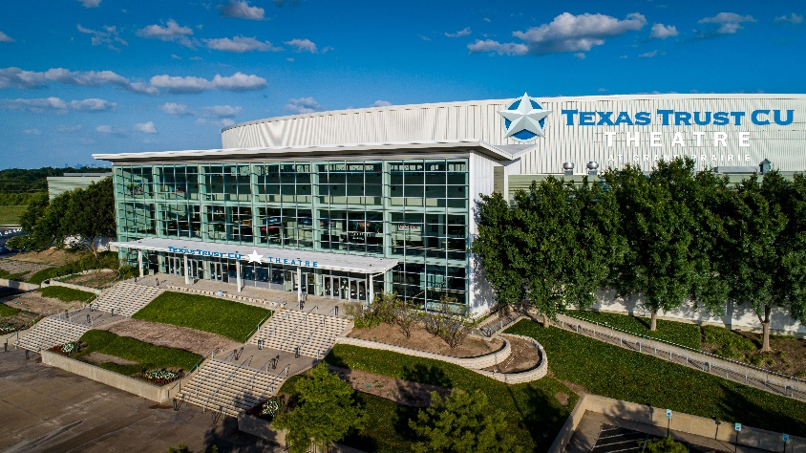
The multi-year sponsorship, brokered by AEG Global Partnerships, affirms the unique and long-standing bond that Texas Trust shares with Grand Prairie and the surrounding communities. Marquee signage for the newly named Texas Trust CU Theatre will be visible from I-30 to hundreds of thousands of people each week.

The theatre, conveniently located adjacent to Lone Star Park, is known for being one of the most versatile concert venues and private event spaces in the country. With a capacity of more than 6,500 guests, it hosts events covering all music genres, as well as corporate gatherings and award shows.

The two-level theatre features state of the art sound, lights, and LED video walls, as well as luxury suites with private bars for entertaining VIPs. Backstage features hospitality rooms and the 8,000-square-foot lobby can be used for receptions, dinners, galas, and private events and concerts.

Since its opening in 2002, the theatre has hosted world-class artists including a variety of rock, country, and comedy shows (Eagles, The Killers, The Lumineers, Dolly Parton, Sturgill Simpson, Kacey Musgraves, Steve Martin, and Tyler Perry), popular hip-hop, R&B/soul, pop and Latin concerts (Tyler, The Creator, Maze, BTS, and Bad Bunny), as well as family-friendly performances and events (Paw Patrol, Hillsong United, and Toby Mac), among many others.

“Texas Trust Credit Union is an integral part of every community we serve, which means more than just doing business here,” said Jim Minge, CEO of Texas Trust Credit Union. “We are an active supporter of the Grand Prairie Independent School District, The Grand Prairie Education Foundation, the Chamber of Commerce, and a number of Grand Prairie-based non-profits. This partnership allows Texas Trust to reinforce our commitment to the city and support a world-class venue that will offer high quality entertainment while also providing substantial economic benefits to the city.”

"We are thrilled two Grand Prairie staples are joining forces with this partnership between Texas Trust and the Theatre at Grand Prairie," said Mayor Ron Jensen. "Both have deep roots in our community, are very involved in making Grand Prairie friendly and progressive, and are perfect community partners. This partnership is music to my ears."

“As the public appetite for live events is reinvigorated, we are thrilled to bring the Texas Trust CU name to The Theatre at Grand Prairie,” said Andrew Klein, Managing Director of AEG Global Partnerships. “Texas Trust has been a valued member of the Grand Prairie community for over 70 years, and together we look forward to continuing to provide unparalleled live entertainment experiences for the residents of Grand Prairie.”

Texas Trust Credit Union began as Chance Vought Aircraft Federal Credit Union in Connecticut. When Chance Vought Aircraft moved its operations to Grand Prairie in 1948, the credit union followed. Today, Texas Trust has two full-service branches in Grand Prairie and a third under construction, which is expected to open this fall. The Texas Trust CU Theatre at Grand Prairie represents the credit union’s ongoing commitment to the people and city of Grand Prairie as well to the entire region.

For more information about the Texas Trust CU Theatre at Grand Prairie and/or to purchase tickets to upcoming events, please visit www.TexasTrustCUTheatre.com.

About Texas Trust Credit Union
Texas Trust Credit Union has been helping build brighter financial futures since its modest beginning in 1936. Today, the full-service credit union serves more than 120,000 members. With assets of more than $1.6 billion, Texas Trust is the 5th largest credit union in North Texas and the 16th largest in Texas. With a focus on the community, Texas Trust is creating a legacy of giving through generous financial donations that support local school programs and activities, non-profit organizations, and student scholarships; and by providing volunteer resources through its Community Unity team, which supports scores of charitable events each year. For more information, visit TexasTrustCU.org or follow us on Facebook at facebook.com/texastrustcu or Twitter at @texastrustcu.

About AEG Presents
Combining the power of the live event with a focus on true artist development, AEG Presents is a world leader in the music and entertainment industries. Operating across four continents, the company has an unparalleled commitment to artistry, creativity, and community. Its tentpole festivals and multi-day music events — which include the iconic Coachella Valley Music & Arts Festival and the legendary New Orleans Jazz & Heritage Festival alongside British Summer Time at Hyde Park, Stagecoach, Hangout Festival, Electric Forest, and Firefly — continue to set the bar for the live music experience. AEG Presents promotes global tours for artists such as The Rolling Stones, Ed Sheeran, Elton John, Taylor Swift, Celine Dion, Justin Bieber, Kenny Chesney, Paul McCartney, and Katy Perry, in addition to — through its network of clubs, theatres, arenas, stadiums and renowned partner brands such as Goldenvoice, Messina Touring Group, Concerts West, The Bowery Presents, PromoWest Productions, Marshall Arts, Madison House Presents, and Zero Mile Presents — creating and developing an unmatched infrastructure for artist development and audience reach. More information can be found at www.aegpresents.com.

###

