Arlington Mayor’s Proclamation Honors Texas Trust CEO Jim Minge

Minge recognized for contributions to the City of Arlington

ARLINGTON, Texas – May 4, 2021 – Since joining Texas Trust Credit Union in 2011, CEO Jim Minge has demonstrated servant leadership as he created a compassionate and caring financial institution dedicated to building brighter financial futures and being a positive community steward.

This month marks Minge’s 10-year anniversary at Texas Trust. During a surprise ceremony at the credit union’s headquarters, Jeff Williams, Mayor of Arlington, issued a proclamation to celebrate and recognize Minge’s contributions. He declared May 3, 2021, as Jim Minge Recognition Day while Minge’s wife, Pat, and the executive team and board of directors were there to witness the memorable occasion.

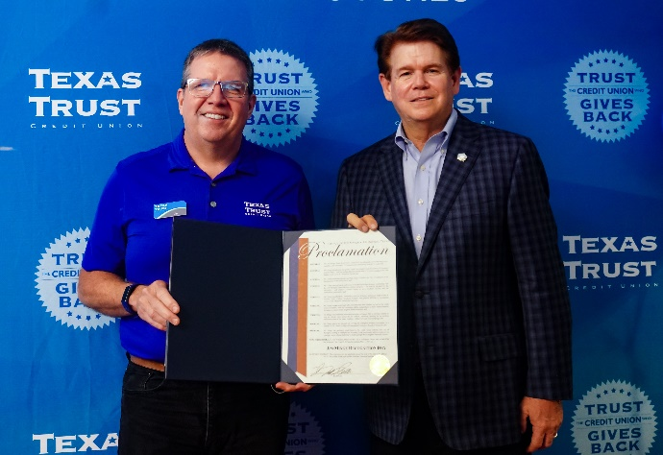
Some of the accomplishments cited in the Mayor’s decree include Texas Trust’s growth from $680,000 in assets to more than $1.6 billion and the doubling of membership to 124,000, making the credit union the fifth largest in Dallas-Fort Worth.

The proclamation also highlighted Minge’s many contributions to the community of Arlington through the credit union’s partnership with the Arlington Independent School District. Texas Trust’s investment in Arlington schools helped fund an outdoor performing arts center and launch the Arlington Collegiate High School at TCC Southeast Campus. In addition, the credit union has invested more than $100,000 in scholarships to benefit Arlington ISD graduates.

The Mayor also highlighted Minge’s commitment to higher education and the credit union’s multi-year, multi-million-dollar agreement with UT Arlington that supports the university’s intercollegiate athletics department.

Minge was recognized for his leadership roles outside of the credit union also, including his current position as a member of the Greater Arlington Chamber of Commerce Board of Directors.

“Jim’s leadership has not only propelled our growth in the last decade, but he has created a work culture that is driven to help other people,” said Larry Skinner, Chairman of the Texas Trust Board of Directors. “Everything Jim does is focused on creating opportunities for people to be more financially secure.”

A copy of the Jim Minge Recognition Day proclamation can be downloaded here, along with high resolution images. Video of the surprise proclamation ceremony can be viewed here.

About Texas Trust Credit Union
Texas Trust Credit Union has been helping build brighter financial futures since its modest beginning in 1936. Today, the full-service credit union serves more than 120,000 members. With assets of more than $1.6 billion, Texas Trust is the 5th largest credit union in North Texas and the 16th largest in Texas. With a focus on the community, Texas Trust is creating a legacy of giving through generous financial donations that support local school programs and activities, non-profit organizations, and student scholarships; and by providing volunteer resources through its Community Unity team, which supports scores of charitable events each year. For more information, visit TexasTrustCU.org or follow us on Facebook at facebook.com/texastrustcu or Twitter at @texastrustcu.

###

Photo Caption: Texas Trust CEO, Jim Minge, was honored with a proclamation issued by Arlington Mayor, Jeff Williams.

