Texas Trust Credit Union Takes Ownership of Former BOA Building

San Angelo, Texas – June 7, 2021 – The former Bank of America building at the corner of West Twohig Avenue and US-277 is undergoing an extensive renovation for its new owner, Texas Trust Credit Union.

The $1.6 billion credit union plans to fully remodel the building inside and out for a new retail branch. The 3,094-square-foot building will provide almost 50 percent more space than the credit union’s current San Angelo Main Street branch.

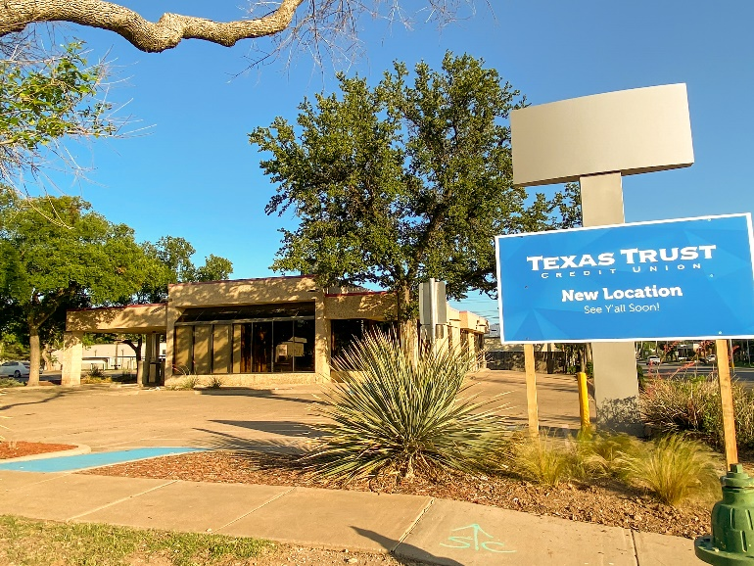
The branch, which is being designed by Interior Design Group, will be an open-floor concept intended to create a collaborative environment. The new design will offer a more personal and innovative member-centric approach that will focus on building member relationships.

This location will offer free-standing universal teller stations that will allow members to conduct all of their financial business with a single teller. In addition, there will be a self-serve station that members can use to review their transaction histories, print statements, and check their balances. The branch will also feature an express teller option for members with simple transactions.

Texas Trust offers San Angelo and Tom Green County residents financial products and services for every stage of life, all designed to help them build brighter financial futures. The new full-service branch will offer checking and deposit services, mortgages for new homes or refinancing, loans for cars and recreational vehicles, low-interest credit cards, insurance and investment services, and more. This branch will also offer three drive-thru lanes, including a wide lane for large vehicles, for contactless service and an exterior drive-up ATM in a well-lit area so members have easy access to their money any time of day.

The new branch will be managed by Victoria Chappa, who currently oversees Texas Trust’s existing downtown location.

“When Bank of America decided to leave the San Angelo Market, we happily stepped in to help people build brighter financial futures,” said Jim Minge, CEO of Texas Trust Credit Union. “We have a long history here and continue to see this community as a great place to invest and grow. We guarantee that our members will be impressed with our new Twohig branch.”

The new branch is scheduled to open in late 2021, replacing the current San Angelo Main branch located at 34 South Main Street.

A high resolution image of the picture shown above can be downloaded here.

About Texas Trust Credit Union
Texas Trust Credit Union has been helping build brighter financial futures since its modest beginning in 1936. Today, the full-service credit union serves more than 120,000 members. With assets of more than $1.6 billion, Texas Trust is the 6th largest credit union in North Texas and the 17th largest in Texas. With a focus on the community, Texas Trust is creating a legacy of giving through generous financial donations that support local school programs and activities, non-profit organizations, and student scholarships; and by providing volunteer resources through its Community Unity team, which supports scores of charitable events each year. For more information, visit TexasTrustCU.org or follow us on Facebook at facebook.com/texastrustcu or Twitter at @texastrustcu.

###

