Texas Trust Credit Union Donates $1,250 to SafeHaven

ARLINGTON, Texas – June 10, 2021 – To help support women and children living in protective shelters due to family violence, Texas Trust Credit Union employees came together to raise $1,250 and donate needed personal goods to Fort Worth’s SafeHaven of Tarrant County.

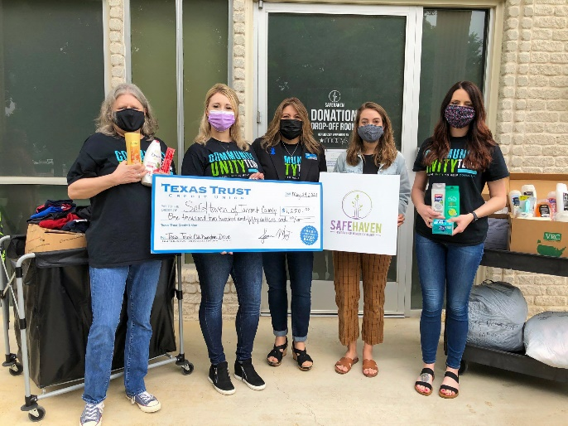
Last year, 17 people died in Tarrant County as a result of domestic violence, a 112 percent increase from 2019. SafeHaven offers a safe place for women and children to escape domestic violence by providing them with shelter, food, counseling, legal aid, and prevention services.

The shelter is currently housing 146 individuals, more than half of them children.

“This contribution allows SafeHaven to provide much needed necessities to the women and children in its care,” said Ginia Chapline, Chief Operating Officer for Texas Trust Credit Union. “When women and children have to leave their homes because of domestic violence, they usually have to leave all of their personal belongings behind.”

Texas Trust’s Community Unity team organized the drive to collect monetary donations as well as shampoo, toiletries, bed sheets, and baby care items, filling 10 banker’s boxes of personal hygiene goods for the shelter.

To download a high resolution image of the above photo, click here.

About Texas Trust Credit Union
Texas Trust Credit Union has been helping build brighter financial futures since its modest beginning in 1936. Today, the full-service credit union serves more than 120,000 members. With assets of more than $1.6 billion, Texas Trust is the 6th largest credit union in North Texas and the 17th largest in Texas. With a focus on the community, Texas Trust is creating a legacy of giving through generous financial donations that support local school programs and activities, non-profit organizations, and student scholarships; and by providing volunteer resources through its Community Unity team, which supports scores of charitable events each year. For more information, visit TexasTrustCU.org or follow us on Facebook at facebook.com/texastrustcu or Twitter at @texastrustcu.

###

Photo caption: Employees from Texas Trust deliver collected items to SafeHaven. (left to right) Kay Robinson, Jessica Moore, Patti Morales, Lindsay Edwards (SafeHaven), and Shannon Barron.

