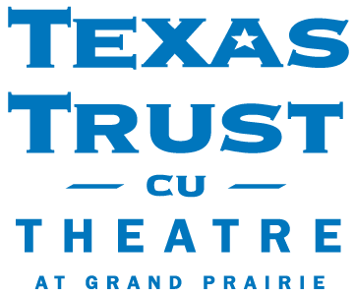
Press Contacts:
Shannon Donnelly, Beck Media
415-318-9716
Shannon.Donnelly@beckmedia.com

Sidney Henderson, Texas Trust Credit Union
shenderson@TexasTrustCU.org
972-595-1017

Kristine Tanzillo, Dux Public Relations
kristine@duxpr.com
903-865-1078

Texas Trust CU Theatre at Grand Prairie Reopening Sept. 10

Tickets are now on sale for all performances

GRAND PRAIRIE, TX –September 8, 2021 – The Texas Trust CU Theatre at Grand Prairie is reopening on September 10 after being closed for more than a year due to the pandemic.

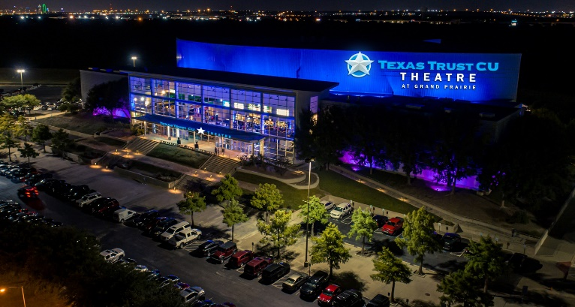
The iconic theatre has more than 45 acts lined up through the end of this year. Performances include concerts from leading artists H.E.R (Oct. 13), REO Speedwagon (Nov. 8) and Bert Kreischer with a double header (Dec. 4) and The Price is Right Live interactive show (Oct. 12). Groove Fest III starring Keith Sweat and Johnny Gill will kick off the busy entertainment schedule on Sept. 10.

The September lineup includes:
The George Lopez OMB HI Comedy Tour, Sept. 11
Iliza: Back in Action Tour, Sept. 18
The Monkees Farewell Tour, Sept. 24
Dropkick Murphys & Rancid, Sept. 28
Boz Scaggs Out of the Blues Tour, Sept. 29

The versatile 6,500-capacity entertainment venue, managed by AEG Presents, is conveniently located adjacent to Lone Star Park. The two-level theatre was refurbished during the pandemic with new paint, floors, and seats. It features state of the art sound, lights, and LED video walls, as well as luxury suites with private bars. An array of distinctive hospitality rooms and an 8,000-square-foot-lobby also offer opportunities for private events and concerts, receptions, dinners, fundraisers, and galas.

The Theatre will also feature the Vought Records shop where attendees can sample music from a virtual jukebox playing one-of-a-kind novelty songs produced for Texas Trust as well as view record covers and music posters featuring clever band titles, such as “The Personal Loans” and “Red Hot Loan Rates.” The Vought Records shop is an interactive entertainment space designed to playfully showcase a variety of Texas Trust’s financial products.

“We are excited about the lineup of live shows that we have scheduled and look forward to delivering a great entertainment experience to the people of Dallas and Fort Worth,” said Robin Phillips, AEG. “We have shows featuring all musical genres, comedy and performers for all ages.”

“With this partnership with the Theatre, we look forward to our members and the community being able to enjoy the variety of concerts and shows that are going to be offered at a great entertainment venue,” said Jim Minge, CEO of Texas Trust Credit Union.

For a full list of shows and to purchase tickets for upcoming events, visit the Texas Trust CU Theatre website.

Ticketholders will be required to show proof of a negative Covid test taken within 72 hours, or at their sole discretion proof of full vaccination, per AEG Presents Health and Safety policy before entry into the theatre.

About Texas Trust CU Theatre at Grand Prairie
Arlington-based Texas Trust Credit Union is the title sponsor of the Texas Trust CU Theatre at Grand Prairie. The theatre, which opened in 2002, can accommodate up to 6,500 patrons for concerts, theatrical productions, comedy shows, galas, corporate presentations, and more. Texas Trust Credit Union has $1.7 billion in assets and more than 120,000 members.

About AEG Presents
Combining the power of the live event with a focus on true artist development, AEG Presents is a world leader in the music and entertainment industries. Operating across four continents, the company has an unparalleled commitment to artistry, creativity, and community. Its tentpole festivals and multi-day music events — which include the iconic Coachella Valley Music & Arts Festival and the legendary New Orleans Jazz & Heritage Festival alongside British Summer Time at Hyde Park, Stagecoach, Hangout Festival, Electric Forest, and Firefly — continue to set the bar for the live music experience. AEG Presents promotes global tours for artists such as The Rolling Stones, Ed Sheeran, Elton John, Taylor Swift, Celine Dion, Justin Bieber, Kenny Chesney, Paul McCartney, and Katy Perry, in addition to — through its network of clubs, theatres, arenas, stadiums and renowned partner brands such as Goldenvoice, Messina Touring Group, Concerts West, The Bowery Presents, PromoWest Productions, Marshall Arts, Madison House Presents, and Zero Mile Presents — creating and developing an unmatched infrastructure for artist development and audience reach. More information can be found at www.aegpresents.com.
###

