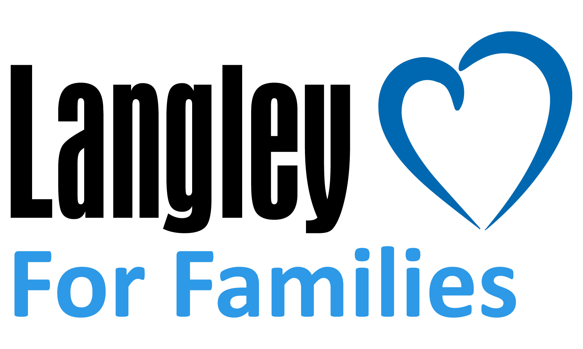

FOR IMMEDIATE RELEASE

Contact: Fred Hagerman, SVP / Chief Marketing Officer, 757.643.8741, fhagerman@langleyfcu.org

Langley For Families Foundation Grants $95,000 to Anti-Human Trafficking Non-Profits

Newport News, Va. – (October 19, 2021) – Langley for Families Foundation announces $95,000 in grants for its annual impact cause funding. FreeKind, Safe House Project, and Survivor Ventures will each receive $25,000. In 2021, the Foundation has adopted the fight against human trafficking as its focus for the year, creating awareness campaigns and providing virtual training for Langley employees.

“These organizations see the worst of humanity every day and continue the fight diligently,” said Foundation Director Laurel Ramey. “It’s our privilege to support their innovative work to help survivors find peace.”

Safe House Project will implement healthcare human trafficking identification and prevention training. The proposal is to design, build, and deploy a survivor-informed, trauma-informed, and patient-centered online training that equips all U.S. healthcare workers to identify potential human trafficking victims, give support, and offer resources.

Survivor Ventures has successfully piloted Survivors to Entrepreneurs (S2E), a program that innovatively addresses economic empowerment for trafficking survivors by offering typical trauma-informed victim services while also increasing employment and wealth-building opportunities for survivors by funding full-time jobs at small business partners.

FreeKind, formerly known as Virginia Beach Justice Initiative, will be adding a transitions coordinator to support its Offramps for Survivors program. FreeKind focuses on intervention efforts within the judicial system or intercepting victims who have been misidentified as criminals, and pre-planning their transition from incarceration to include shelter, transportation, and other support services.

Additionally, Samaritan House and Transitions Family Violence Services will both receive $10,000 grants.

Langley Federal Credit Union has a long history of community involvement and charitable giving dating back to the founding of the credit union in the 1930's. With a commitment to making a difference in the communities it serves, Langley for Families Foundation was launched in 2014 to support causes and charities benefiting children and families.

Langley Federal Credit Union is a federally-chartered credit union, regulated and insured by the National Credit Union Administration. Langley Federal Credit Union serves more than 300,000 members and has nearly $4 billion in assets, ranking the financial cooperative as one of the 100 largest credit unions in the country. Langley is a full-service financial institution where everyone can save, borrow, and spend wisely. Located in Hampton Roads, Langley has 19 branches and more than 55,000 surcharge-free ATMs throughout the region. For more information, visit www.langleyfcu.org.

###

Photo Caption: Lisa Kersey (L), Executive Director of FreeKind and Laurel Ramey (R), Langley For Families Foundation Director

