Press Contacts:
Krysten Koval, Director of Marketing
972-348-2367
Krysten_Koval@texanscu.org

Kristine Tanzillo, Dux Public Relations
903-865-1078
kristine@duxpr.com

Texans Credit Union Treats Immune-Compromised Children
to Trunk or Treat Halloween Party

Richardson, TX (November 5, 2021) – More than 50 children with life-threatening illnesses experienced the fun of Halloween at a special Trunk or Treat event hosted by Texans Credit Union.

For the sixth year, Texans partnered with HopeKids to offer a safe and fun Halloween adventure for seriously ill children and their siblings. The children from HopeKids have medical conditions that make it difficult for them to enjoy traditions such as neighborhood Trick or Treating.

Employees from the credit union turned their parking garage into a Halloween setting featuring creatively designed vehicle trunks, carnival style games, and lots of candy stations that the children could visit.
The HopeKids Trunk or Treat event allowed children to experience and enjoy the Halloween tradition of dressing up and going trunk to trunk to play games and collect candy in a safe environment, away from large public crowds. The event also gave parents an opportunity to socialize with others going through similar medical situations where they could connect, share, and encourage each other.
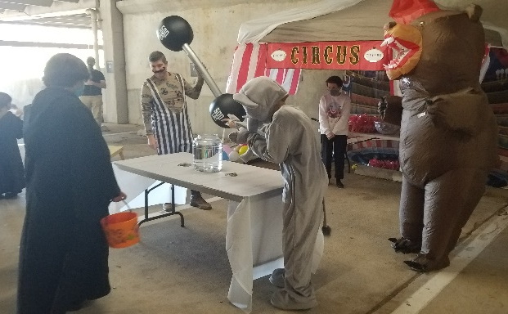
“It is a beautiful moment to see the faces of these children light up when they get to do things like trick or treat that most children take for granted,” said David Frazier, president of Texans Credit Union. “HopeKids not only offers hope for the children and families it serves, but gives our employees an opportunity to help make a difference in these children’s lives.”

HopeKids’ mission is to provide opportunities and transform the lives of children with life-threatening illnesses, underlining the message that hope is a powerful medicine.

You can view a short video from the Texans CU HopeKids Trunk or Treat event here.

About Texans Credit Union
Texans Credit Union is a full-service, not-for-profit financial institution that serves more than 110,000 members throughout the DFW area. With more than $2 billion in assets, Texans Credit Union is one of the largest member-owned financial institutions in the DFW area, serving its members and the community since 1953.

###

