


Greater Texas Credit Union Dedicates
New Headquarters Facility in Austin

AUSTIN, December 6, 2021 – Greater Texas Credit Union dedicated its new headquarters facility in Austin December 3 with a ribbon cutting and grand opening celebration.

The new facility allows the credit union to house all of its administrative and back-office departments in a single location to maximize internal communication and increase productivity. The headquarters staff also serve Greater Texas’ subsidiary credit union, Aggieland Credit Union, which serves the Bryan-College Station and Brazos Valley area.

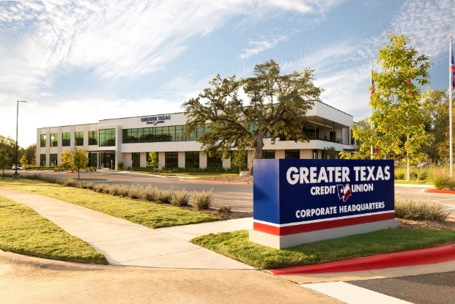
The two-story building, which is across the street from the Apple campus, provides 50,575 square feet of office space. Already Greater Texas has taken advantage of that ample space to grow its contact center and add agents to better, and more quickly, serve its more than 75,000 members’ needs. The facility also allows the 80 Greater Texas employees now working there to collaborate more effectively. The new facility is a 30-year solution that can accommodate up to 250 employees as Greater Texas continues its steady growth in membership and assets.


“Our employees now enjoy a top-tier work environment in which they can thrive, connect with each other, and easily access on-site benefits,” said Howard N. Baker, President and CEO of Greater Texas Credit Union. “In addition to offices, our building features quiet rooms, a commons area, workout facilities and showers, and walkable trails right outside our door.”

Greater Texas has been ranked as a Top Workplace for many years, and its new headquarters will help the credit union attract and retain employees, said Baker. He added that with all of the administrative and back-office people in one place at last, the move has created synergy and efficiencies in member service, Greater Texas’ top priority.

For the grand opening and ribbon cutting event, the credit union hosted local officials and special guests, who toured the facility and enjoy live music and refreshments.



About Greater Texas
Greater Texas Credit Union, founded in 1952, is a financial cooperative that provides an array of personal financial products and services. Together with its subsidiary, Aggieland Credit Union – which serves the Brazos Valley – it offers a wide variety of consumer oriented banking services to its 77,000 members across the state of Texas. Greater Texas has locations in Austin, Houston, San Antonio, Bryan-College Station, Edinburg, and the DFW market with assets of nearly $1 billion.

###

Photo caption 1: The 50,575 square foot headquarters of Greater Texas Credit Union is located across the street from the Apple campus in the Riata Vista area.

Photo caption 2: Howard N. Baker, President and CEO of Greater Texas Credit Union.

Photo caption 3: Howard Baker, President and CEO of Greater Texas Credit Union (2nd from left) stands ready to cut the ribbon of the credit union’s new 50,000 square foot facility in the Riata Vista area of Austin. Standing with Howard are (left to right) Daniel Sleboda, Austin Chamber Ambassador, Howard Baker, Wesley Yeager, Greater Texas Credit Union Board of Directors Chairman, Veronda L. Durden Greater Texas Credit Union Board of Directors First Vice Chairman, Charlotte Schneemann Greater Texas Credit Union Board of Directors Treasurer, Penny Rychetsky, Former Greater Texas Credit Union Board of Directors Chairman, Ms. Jeffery Archer, former Greater Texas Credit Union Board of Directors Member, and Karen Cole, Customer Success Manager, Austin Chamber of Commerce.

