PRESS CONTACTS:

Sidney Henderson
Rachel Bond
Greater Texas Credit Union
Marketing@GTFCU.org
(512) 323-4732
Kristine Tanzillo
Dux Public Relations
Kristine@DUXPR.com
(903) 865-1078

Greater Texas Credit Union Gives $10,000 to
Help the Homeless in Austin

AUSTIN, December 7, 2021 – As part of Greater Texas Credit Union’s dedication of its new headquarters, the credit union has donated $10,000 to Mobile Loaves & Fishes and the Austin chapter of the Salvation Army. Each charity will receive $5,000 to be used to support their homeless programs.

Mobile Loaves & Fishes feeds and provides shelter for the homeless. The group is developing the second phase of its Community First! Village, a master planned development that provides affordable, permanent housing for men and women who are transitioning out of chronic homelessness. The Community First! Village also provides community support through employment opportunities, easy access to public transportation, a community market, and health and wellness services.

The Salvation Army of Austin oversees three housing-focused shelters in Austin that provide an array of services to help transition people off the street into permanent housing. It also provides financial assistance for utilities and food, as well as life skills to help the homeless escape poverty, through rehabilitation, job training, and more.

“As an Austin-based institution, we have a responsibility to help provide for our neighbors in need,” said Howard N. Baker, President and CEO of Greater Texas Credit Union. “Homelessness in Austin is a clear and present problem that truly takes a village to address. The Austin Salvation Army and Mobile Loaves & Fishes deliver exceptional care and compassion for those making the transition from living on the street to self-sufficiency, offering real solutions that address the root causes of homelessness.”

Greater Texas presented Mobile Loaves & Fishes and the Salvation Army each with a check during the grand opening celebration of its new headquarters at 12544 Riata Vista Circle. Guests at the Friday event enjoyed live music and refreshments and took a tour of the facility.
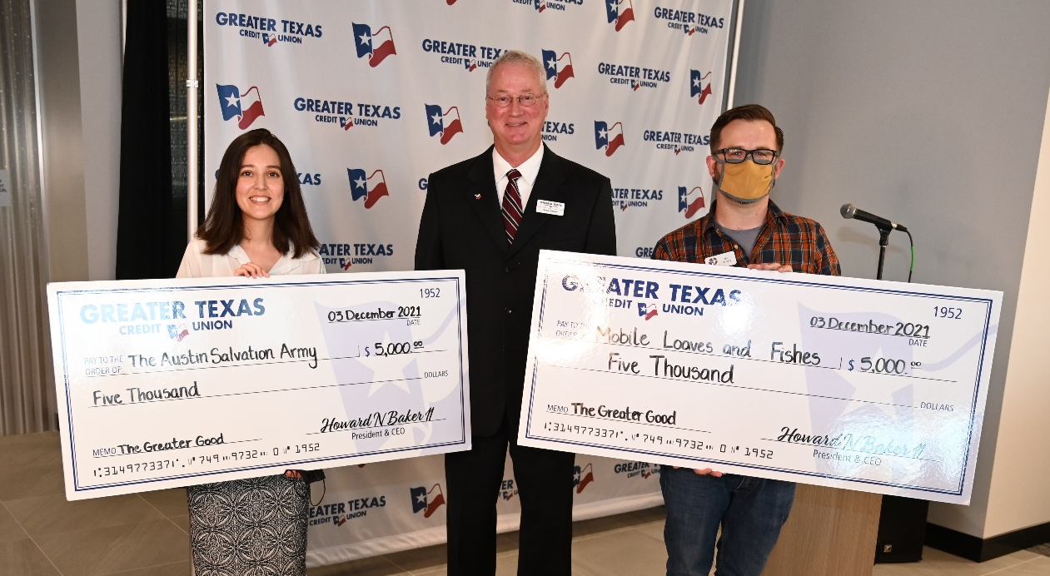
Baker added, “We hope our donation to these two fine charities will help our homeless neighbors find a pathway that gives them hope and support so that they can overcome their challenges. We want to help them succeed.”

About Greater Texas
Greater Texas Credit Union, founded in 1952, is a financial cooperative that provides an array of personal financial products and services. It offers a wide variety of consumer-oriented banking services to its 77,000 members across the state of Texas. Greater Texas has locations in Austin, Houston, San Antonio, Bryan-College Station, Edinburg and the DFW market with assets of nearly $1 billion.
###
Photo caption: As part of the christening of its new headquarters, Howard Baker, the President and CEO of Greater Texas CU donated $10,000 to two Austin charities that serve the homeless. Pictured with Baker is Audrey Vivar with the Salvation Army and Ed Travis with Mobile Loaves and Fishes, each receiving $5,000 from the credit union.

