FOR IMMEDIATE RELEASE

CONTACT:
Julie Woloszyn, Director Brand Awareness
Corporate Central Credit Union
(414) 425-5555

Corporate Central Garners Nationwide Participation in Virtual Digital Marketing Forum

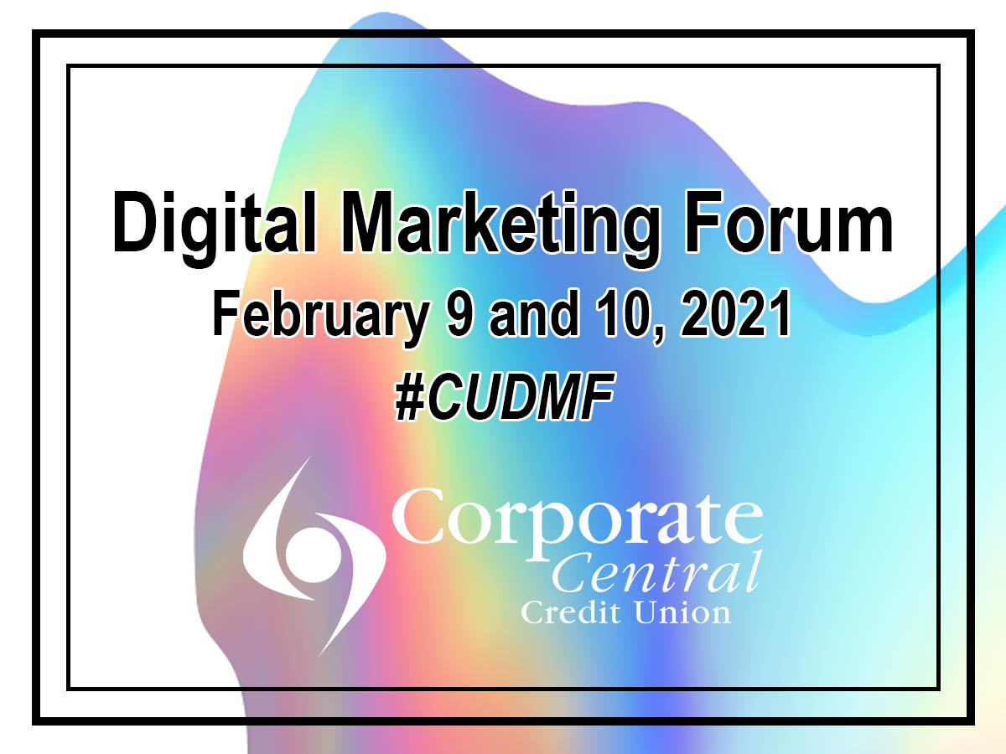
MILWAUKEE, WI – February 16, 2021 – Credit union professionals from across the country participated in Corporate Central’s Digital Marketing Forum held virtually Tuesday and Wednesday last week. Presenters covered topics including digital excellence, SEO and accessibility, marketing digital banking, and other trending digital marketing topics to over 140 registered attendees.

“This is the second time Corporate Central has hosted this event, but the first time hosting virtually,” said Jesse Kohl, Senior Vice President Corporate Development. “It was fantastic to see so many credit union marketing professionals from coast-to-coast attend our forum. We appreciate all of the presenters and panelists for their time, insights, and advice, and we sincerely hope all the attendees learned valuable information to take back to their credit unions.”

Speakers and topics covered included:

- Virginia Heyburn, Vice President Business Development at Fiserv Global Sales Organization, presented ways in which credit unions should be adapting and growing to keep up with the FinTechs. She discussed next-level financial services that are conversational, fast, snackable, and embedded, with ways for credit unions to deliver finely tailored advice and services instantly.

- Diane Kulseth, Senior SEO Consultant at Siteimprove, presented on the importance of building a stronger user experience with websites. She took the audience on a deep dive into the overlap between search engine optimization (SEO) and accessibility, and why it is more important than ever to include accessibility in their SEO arsenals.

- From Finastra, Amber Sappington, Head of Data and Analytics, and Merrijo Hale, Sales Executive, presented opportunities for credit unions to utilize artificial intelligence and machine learning to better understand member behavior. They discussed how to use data to improve strategic planning and execute and analyze marketing campaigns.

- Sarah Best, CEO + Chief Strategist of Sarah Best Strategy, demonstrated how credit unions can use Google Analytics to align social media campaigns with company goals. She discussed details demystify marketing metrics like bounce rates, and shared actionable advice with the audience.

The two-day event concluded with a peer discussion moderated by Tony Hill, SVP/Chief Marketing Officer at CUES. The group of progressive credit union leaders included:

- Ben Bauer, CUDE, VP of Awesomeness (Marketing)
Simplicity Credit Union and Exclamation Services CUSO

- Paul Kurth, Digital Branch Manager
Connexus Credit Union

- Erika Hill, Vice President of Marketing
Trellance

- Tim McAlpine, CEO
Currency Marketing

“Our goal with the Digital Marketing Forum is to help credit unions prosper in this ever-changing digital age,” said Kohl. “We are optimistic this event equipped them with some tools to help them along the way.”

Helping Members to be Wildly Successful

About Corporate Central Credit Union
Corporate Central Credit Union is a federally insured financial cooperative built on the values of commitment to service, fiscal responsibility, and respect for the individual. We cultivate a culture of respect, ethics, teamwork, and innovation. We are "Helping Members to be Wildly Successful" by delivering industry knowledge and expertise to help credit unions achieve their strategic objectives and compete in today’s evolving financial services industry. We are motivated to passionately serve our members and strive to learn, create, and innovate daily. Please visit corpcu.com to learn more, and follow us on LinkedIn, Facebook, Twitter, and YouTube.

