FOR IMMEDIATE RELEASE

CONTACT:
Julie Woloszyn
Director Professional Development & Communications
Corporate Central Credit Union
(414) 425-5555

Over 500 Credit Union Fans Attend Corporate Central and The League’s Credit Union Day at the Ballpark

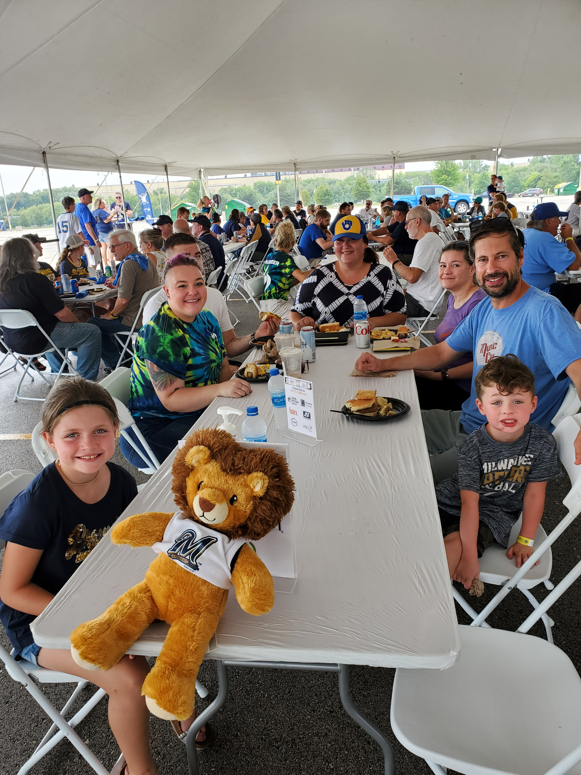
MILWAUKEE, WI – August 12, 2021 – On Sunday, August 8, Corporate Central and The Wisconsin Credit Union League (The League) hosted Credit Union Day at the Ballpark, a fundraising event that raised over $15,000 for The Wisconsin Credit Union Foundation and The National Credit Union Foundation.

The collaborative event brought credit union members, families, friends, employees, and supporters together as the Milwaukee Brewers took on the San Francisco Giants at American Family Field in Milwaukee, WI.

“After a long while apart, it was so great to see more than 500 credit union people come together and take part in this event,” said Chris Felton, President/CEO of Corporate Central. “Working together with the wonderful people at The League to host a fundraising event like this is exactly what our movement is all about – people helping people.”
Credit union fans flocked to the tailgate party preceding the game for brats, burgers, networking, and an all-around good time.

Brett Thompson, President/CEO of The League added, “Although the Brewers were bested by the Giants, it was truly special to be able to safely gather to see credit union friends and colleagues face-to-face after 17-months and raise funds for a good cause while doing so.”

This event was made possible by the generous sponsorships of Fiserv, CUNA Mutual Group, FHLBank Chicago, Strategic Resource Management, Inc. (SRM), Shazam, and PSCU.

About Corporate Central Credit Union
Corporate Central Credit Union is a federally insured financial cooperative built on the values of commitment to service, fiscal responsibility, and respect for the individual. We cultivate a culture of respect, ethics, teamwork, and innovation. We are "Helping Members to be Wildly Successful" by delivering industry knowledge and expertise to help credit unions achieve their strategic objectives and compete in today’s evolving financial services industry. We are motivated to passionately serve our members and strive to learn, create, and innovate daily. Please visit corpcu.com to learn more, and follow us on LinkedIn, Facebook, Twitter, and YouTube.

About The Wisconsin Credit Union League
The League is the dues-supported trade association for Wisconsin's credit unions – not-for-profit financial institutions that are cooperatively owned by their more than 3 million members. Based in Madison, The League is dedicated to serving Wisconsin's credit unions and promoting the credit union difference through advocacy, education, and public service.

