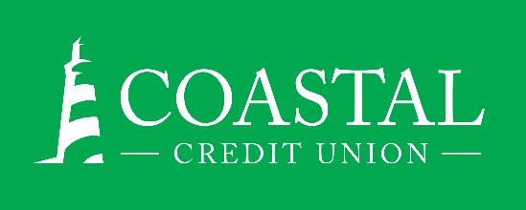
NEWS RELEASE
Contact: Joe Mecca
VP, Communication / Spokesperson
919-420-8044 /jmecca@coastal24.com
FINAL – For Immediate Release

Coastal Credit Union Collects Two Marketing Awards
RALEIGH, N.C. (April 22, 2021) – Coastal Credit Union has earned two more awards in recognition of their marketing efforts.

The CUNA Marketing & Business Development Council has awarded Coastal with a Diamond Award in the Ongoing Event category for the credit union’s 2020 Town Hall Meeting. This is Coastal’s 4th Diamond Award in the past three years, and 23rd overall.

Additionally, Coastal’s Digital Technology campaign commercials were acknowledged with a Bronze award in the TV category of the American Advertising Federations’ Addy Awards. The credit union’s advertising and marketing partners at SEEZ produced the commercials and submitted them for an award on Coastal’s behalf. The highly-competitive contest attracts more than 40,000 entries.

About Coastal
Coastal Credit Union is a not-for-profit, member-owned, financial cooperative, offering a full range of financial products and services. Coastal was chartered on August 31, 1967 with the mission of fostering the credit union philosophy of “people helping people.” Today, with $4.2 billion in assets, Coastal serves 282,000 members from 1,800 business partners and is among the leading financial institutions in North Carolina. Coastal operates 23 branches in central North Carolina and serves members in all 50 states through a network of 5,000 shared branches, 30,000 surcharge-free ATMs, mobile banking featuring mobile check deposit, and a robust offering of online services at www.COASTAL24.com. For more Coastal news, visit our online newsroom.
###

