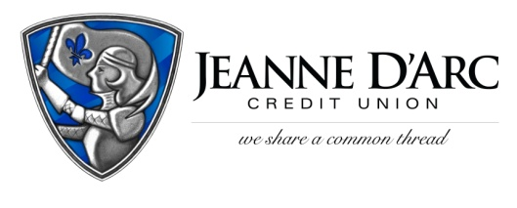

FOR IMMEDIATE RELEASE CONTACT: Robin Lorenzen
WITH PHOTO 978-323-3226
June 22, 2021

Jeanne D’Arc Credit Union Awards $17,000 in College Scholarships

LOWELL, MA – To help defray the costs of higher education for local college students, Jeanne D’Arc Credit Union awarded $17,000 in college scholarships to members through its MoneyStrong College Scholarship and Employee Scholarship Programs. The recipients are comprised of both soon-to-be and current college students.
The winners of the 21st annual MoneyStrong College Scholarship Program were asked to write an essay in response to the following prompt: “Credit is borrowed money that you can use to purchase goods and services when you need them. In your essay, explain why credit is important, and how a good credit score can help you achieve your goals.”
The Credit Union granted funds to 21 students. Of the winners, 17 are high school seniors gearing up for their freshman year of college, and 4 are currently attending various colleges in the area.
Through the Employee Scholarship Program, Jeanne D’Arc Credit Union employees, as well as an employee’s child or grandchild, are eligible to receive a $500 or $1,000 scholarship. There are six different scholarships available, three of which were instituted to memorialize former Jeanne D’Arc employees and board members, and three were awarded commemorating the Credit Union’s commitment to supporting local non-profit organizations. The Credit Union awarded a total of $4,500 through the Employee Program.
Recipients are typically honored at an on-site ceremony at Jeanne D’Arc’s headquarters, but given the current restrictions, all recipients were notified and mailed their scholarship awards. They will also be featured on Jeanne D’Arc’s social media accounts.
“We congratulate and celebrate these individuals for their hard work and commitment to education,” said Mark S. Cochran, President & CEO, Jeanne D’Arc Credit Union. We are happy to support them in their quest to fulfill their dreams through our scholarship program.”

The MoneyStrong scholarship winners include:
Mackenzie Jacques from Alvirne High School, University of New England; Ryann Dionne from Alvirne High School, Worcester Polytechnic Institute; Michelle Ly from Chelmsford High School, University of Mass- Lowell; Joseph Luis Dulac from Dover High School, Georgia Institute of Technology; Jason Tyler from Dracut High School, University of Connecticut; Lilly Saadah from Dracut High School, University of Mass- Lowell; Skylar Phan from Dracut High School, University of Connecticut; Andrew Shapiro from Innovation Academy Charter School, Fordham University; Donna Ly from Lowell High School, Unverisity of Mass- Lowell; Edmire Kabia from Lowell High School, University of Mass- Lowell; Matthew Chege from Lowell High School, Howard University; Timothy Xuan Nguyen from Lowell High School, University of Mass- Lowell; Haylee Coupal from Pinkerton Academy, University of Mass- Lowell; Kylie Coupal from Pinkerton Academy, Rivier University; Halle Bangura from Tyngsboro High School, Princeton University; Trevor Freelove from Tyngsboro High School, University of Tampa; Rachel Junta from Wakefield Memorial High School, Umass Amherst; Ellen McKenna, Saint Michael's College; Taylor Gibson, Springfield College; Patrick McKenna, Worcester Polytechnic Institute; Camryn Santiago, Rivier University.
Recipients of the Employee Scholarships include: Paige Dame, University of New Hampshire; Jason Ugles, Clark University; Jason Kapodistrios, Syracuse University; Samantha Fagundes, Merrimack College; Hannah Dumont, Anna Maria College; Katherine Rojo, Middlesex Community College.
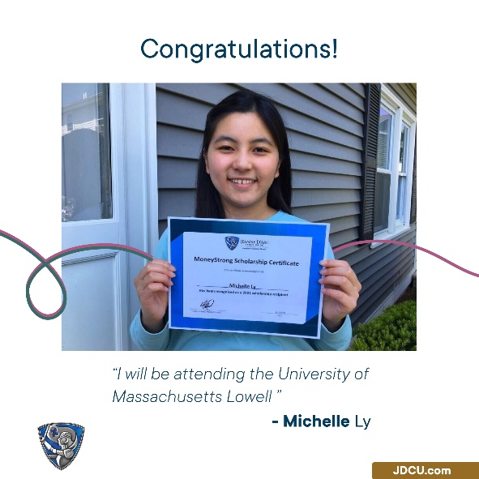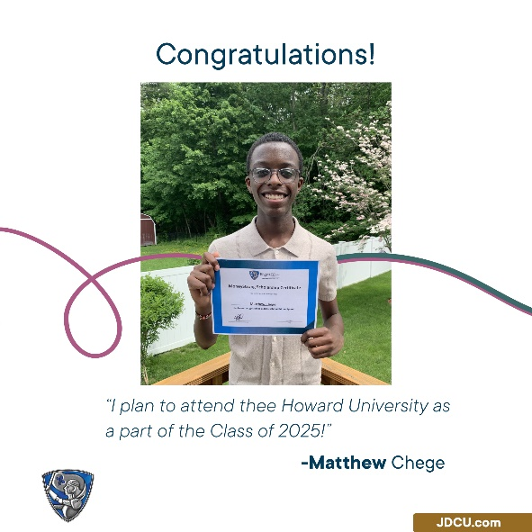
Photo cutline: Jeanne D’Arc Credit Union Scholarship winners display their awards.
###
About Jeanne D’Arc Credit Union:
Jeanne D’Arc Credit Union was established in 1912 and is a full-service, community-based financial cooperative. Locally owned by 93,000 members with $1.7 billion in assets, Jeanne D’Arc operates eight full-service branches in Lowell, Dracut (2), Tyngsboro, Chelmsford, Methuen and Westford, Massachusetts and Nashua, New Hampshire; high-school branches at Lowell High, Dracut High, and Nashua High School South; a loan center in Lowell; and a mortgage center in Chelm

