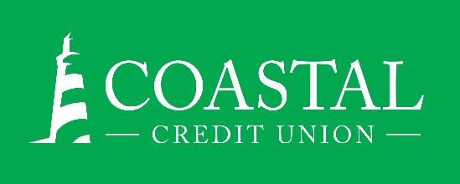
NEWS RELEASE
Contact: Joe Mecca
VP, Communication / Spokesperson
919-420-8044 /jmecca@coastal24.com
FINAL – For Immediate Release

Coastal Credit Union Named Among
Triangle’s Healthiest Employers for the Eleventh Time
RALEIGH, N.C. (September 29, 2021) – Coastal Credit Union has been recognized as one of the Healthiest Employers of the Triangle for 2021, an awards program created to honor people-first organizations that prioritize the well-being of their employee population. These companies were recognized because of their commitment to workplace wellness and their exceptional health and benefits offerings. Over the past year and a half, several companies have adapted to remote workforces and new policies because of the global pandemic.
Award applicants were evaluated across six key categories: Culture and Leadership, Foundational Components, Strategic Planning, Communication and Marketing, Programming and Interventions, and Reporting and Analytics. Completed assessments were ranked with the proprietary Healthiest Employers® Index, a 1-100 rubric for wellness programming. The survey is scored and powered by Springbuk, a health intelligence platform that simplifies data-driven decision-making with an intuitive user experience, predictive modeling, and curated action steps.
This is the eleventh time that Coastal has been named a Healthiest Employer of the Triangle, including the past six years in a row. It is one of four employer awards that the credit union has earned this year.

About Coastal
Coastal Credit Union is a not-for-profit, member-owned, financial cooperative, offering a full range of financial products and services. Coastal was chartered on August 31, 1967 with the mission of fostering the credit union philosophy of “people helping people.” Today, with $4.38 billion in assets, Coastal serves 292,000 members from 1,800 business partners and is among the leading financial institutions in North Carolina. Coastal operates 23 branches in central North Carolina and serves members in all 50 states through a network of 5,000 shared branches, 80,000 surcharge-free ATMs, mobile banking featuring mobile check deposit, and a robust offering of online services at www.COASTAL24.com. For more Coastal news, visit our online newsroom.
About Springbuk and Healthiest Employers®:
Springbuk is a health intelligence software platform that empowers everyone in an employer’s health ecosystem to glean actionable insights to improve their population’s well-being and contain claims costs. Each year, Springbuk administers the Healthiest Employers® Awards Program across the country to honor the nation’s most dedicated employers in bettering their worksite health and wellness programs. To date, over 10,000 employers across 40+ U.S. cities have participated in the awards program. Learn more at www.Springbuk.com. and www.HealthiestEmployers.com.
###

