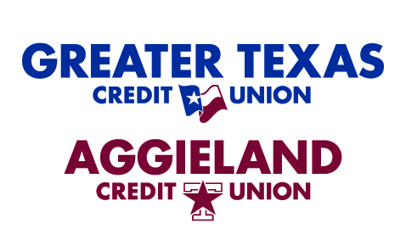

PRESS CONTACTS:
Sidney Henderson | Kristine Tanzillo | Jeff Chesky
Rachel Bond | Dux Public Relations | Insuritas
Greater Texas Credit Union | Kristine@Duxpr.com | jchesky@insuritas.com
Marketing@GTFCU.org | (903) 865-1078 | 860-653-1132
(512) 323-4732

Greater Texas | Aggieland Credit Union Launches Insurance Agency Through Partnership with Insuritas

Austin and East Windsor, CT (January 18, 2022) – Greater Texas | Aggieland Credit Union has partnered with Insuritas to offer insurance brokerage services to its more than 77,000 members.
The insurance agency, Greater Texas | Aggieland Insurance Solutions, is a wholly owned subsidiary of Greater Texas Credit Union. It offers personal, ancillary, and commercial insurance products following Greater Texas’ convenient, digital-first member services model.
“As part of our strategic planning process, we assessed the services available to our members. After careful analysis, we determined that with Insuritas we can provide our members with new options to help them work toward their financial goals and manage their risks,” said Greater Texas Vice President of Financial Solutions Joe James. “Affordability, convenience, and quality of insurance offerings are some of the benefits the agency will provide our members.”
The Greater Texas | Aggieland Insurance Solutions will include more than 40 carrier partners with products such as home, renter’s, auto, pet, identity theft, and travel, among many others.
“We’re delighted to announce our relationship with Greater Texas Credit Union and are proud to have earned the opportunity to build, launch, and manage a full-service, digitally powered insurance agency for their members,” said Insuritas Chairman and CEO Jeffrey Chesky. “Through our relationship, the credit union will now be able to provide simple, seamless access to competitive options for their members’ insurance needs, all with a focus on delivering the right coverages at the right price at the right time.”
Greater Texas members can obtain a free no-obligation insurance rate quote online from Greater Texas | Aggieland Insurance Solutions or by calling toll-free, 866-452-0719.
About Insuritas
The Insuritas mission is to connect people to the insurance products they need through a seamless, transparent shopping experience where carriers compete to provide them with the right coverage at the right price. The Insuritas meta-agency platform, deployed across a network of partners serving over 10M customers nationally, empowers financial institutions to leverage proprietary data-mining techniques and integrations with a broad array of insurance carriers to make highly personalized, digitally optimized insurance offers to their depositors, all within their brand. These strategies help further their commitment to the financial well-being of their customers, while driving a critical source of non-interest income for their institution. For more information, visit www.insuritas.com.

About Greater Texas | Aggieland Credit Union
Greater Texas Credit Union, founded in 1952, is a financial cooperative that provides an array of personal financial products and services. Together with its subsidiary, Aggieland Credit Union – which serves the Brazos Valley – it offers a wide variety of consumer oriented banking services to its 77,000 members across the state of Texas. Greater Texas has locations in Austin, Houston, San Antonio, Bryan-College Station, Edinburg, and the DFW market with assets of nearly $1 billion.

# # #

