Arlington Women’s Alliance Names Washima Huq Rising Star

ARLINGTON, Texas – March 7, 2022 – Executive Director Washima Huq of the Texas Trust Gives Foundation, the non-profit arm of Texas Trust Credit Union, has received the Rising Star award from the Greater Arlington Chamber’s Women’s Alliance.
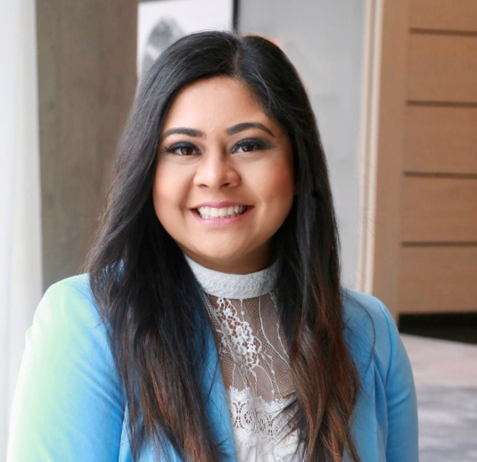
Huq was recognized as the 2022 Rising Star for her unwavering dedication to the mission of enhancing the city of Arlington and its surrounding communities through professional, volunteer, and charitable endeavors and civic engagement. The annual award is presented to a woman who demonstrates servant leadership and humbly puts others before herself.

In her role at the Texas Trust Gives Foundation, Huq oversees the charitable giving of the $1.8 billion Texas Trust Credit Union. She is an active community and industry leader, serving on advisory boards and committees for the Asian Business Council, the Greater Arlington Chamber of Commerce, the Cooper Street YMCA, Arlington Women’s Alliance, Mansfield ISD Superintendent’s Advisory Council, and Cornerstone League’s Young Professionals Group.

“Washima is passionate about helping others advance in their personal and professional pursuits,” said Ginia Chapline, COO for Texas Trust Credit Union. “She acts out of compassion and the desire to lift others up. We are delighted that she is the recipient of this award. It is well deserved.”

Huq was presented with the Rising Star award during the Greater Arlington Women’s Alliance Inspired Women Luncheon.

High resolution images of Huq can be downloaded here.

About Texas Trust Credit Union
Texas Trust Credit Union has been helping build brighter financial futures since its modest beginning in 1936. Today, the full-service credit union serves more than 133,000 members. With assets of more than $1.8 billion, Texas Trust is the 6th largest credit union in North Texas and the 16th largest in Texas. With a focus on the community, Texas Trust is creating a legacy of giving through generous financial donations that support local school programs and activities, non-profit organizations, and student scholarships; and by providing volunteer resources through its Community Unity team, which supports scores of charitable events each year. For more information, visit TexasTrustCU.org or follow us on Facebook at facebook.com/texastrustcu or Twitter at @texastrustcu.

###
Photo Caption: Arlington City Council Members Dr Victoria Farrar-Myers and Raul Gonzales pose with Washima Huq.

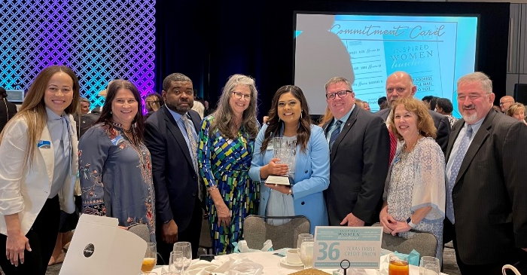
Photo Caption: Tyra Garcia, Shelia Kime, Ron Smith, Debi Knoblock, Washima Huq, Jim Minge, David Turner, Ginia Chapline, and Willy Kelsey.

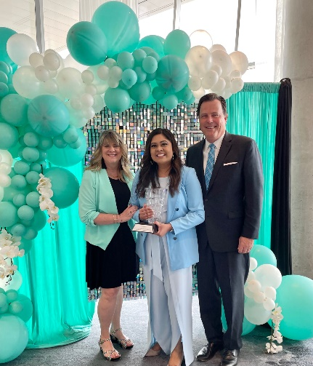
Photo Caption: Greater Arlington Chamber President Michael Jacobson, Washima Huq, and Senior Director of Investor and Board Relations/Chamber Liaison of Women’s Alliance Sherry Jackson.

Photo Caption: Darla Peznell, the Chair of the Greater Arlington Chamber’s Women’s Alliance, presents Washima Huq the 2022 Rising Star award.

