Texas Trust Credit Union Saw Outstanding Growth in 2021
Building on Equally Strong 2020, Credit Union Grew in All Major Categories
ARLINGTON, Texas – March 21, 2022 – Texas Trust Credit Union posted outstanding growth in all categories in 2021, the credit union announced in conjunction with its annual meeting.

Total assets, loans, and deposits all increased at a double-digit growth rate in 2021, as Texas Trust built on 2020, also a highly successful year for the credit union. Here are the highlights of Texas Trust’s financial year:
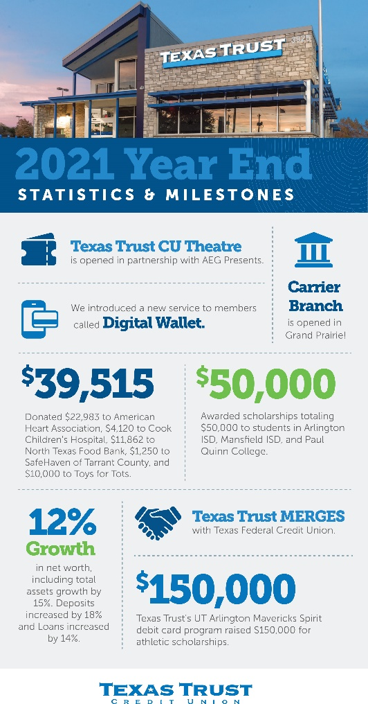
TOTAL ASSETS: Total assets for Texas Trust climbed by 15 percent, continuing the strongest growth in years and building on the 2020 growth rate of 16.3 percent. Over the past four years, the credit union has seen assets grow from $1.22 billion to $1.8 billion, more than 47 percent.

LOANS: With powerful loan growth of 14.7 percent in 2021 on top of 18.7 percent growth in 2020, Texas Trust ended the year with $1.3 billion in outstanding loans. That represents a four-year growth of 43.5 percent.

DEPOSITS: The amount of deposits grew 11.8 percent in 2021, again building on a 16.9 percent growth rate in the pandemic-impacted year of 2020. Texas Trust’s deposits stood at $1.47 billion at the end of 2021. That is more than half a billion dollars more than at year-end 2017, a four-year growth rate of 52 percent.

MEMBERSHIP: Texas Trust added almost 11,000 members during 2021, growing its total membership by 8.8 percent during the year. That is the greatest growth the credit union has seen in years, and represents a four-year growth rate of 16.3 percent.

“In our view, 2021 is the year that we at least began to return to normalcy,” said Jim Minge, CEO of Texas Trust. “But it was still an anomalous year because we had so many members with excess cash from the stimulus checks they received.

“Where we saw the effect of that was in certain lending categories. Our overall lending was up and strong, but there were large variations in some types of lending.”

One area where lending was way up, Minge explained, was in pre-owned vehicles. “With new auto production down due to supply chain issues and the prices of pre-owned vehicles climbing steeply, we logged record numbers in the used vehicle category.”

Texas Trust did change its approach to lending in 2021, taking a more holistic view of members who applied for loans, Minge noted.

“We moved beyond such a strong reliance on credit scores and looked at each individual loan application on its own merits. One thing the pandemic made much clearer was that bad things financially can happen to good people. We recognized this and adjusted accordingly.”

That was just one of the changes that Texas Trust implemented in 2021 that Minge believes will make for an even stronger year this year.

“More than ever, we now look for ways that we can truly help members who need it. This is an ongoing mission, that involves more than just altering our lending guidelines. It means meeting our members when and where their needs are greatest.”

Also in 2021, Texas Trust merged with the former Texas Federal Credit Union, added another branch in Grand Prairie, and revamped its community giving approach by developing the Texas Trust Gives Foundation, which officially launched in early 2022. The credit union also took on a major sponsorship of what is now the Texas Trust CU Theatre in Grand Prairie.

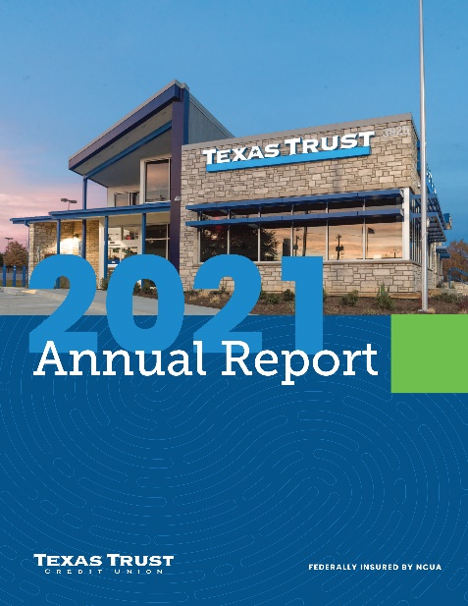
A copy of the Texas Trust 2021 Annual Report is available here.

About Texas Trust Credit Union
Texas Trust Credit Union has been helping build brighter financial futures since its modest beginning in 1936. Today, the full-service credit union serves more than 133,000 members. With assets of more than $1.8 billion, Texas Trust is the 6th largest credit union in North Texas and the 17th largest in Texas. With a focus on the community, Texas Trust is creating a legacy of giving through generous financial donations that support local school programs and activities, non-profit organizations, and student scholarships; and by providing volunteer resources through its Community Unity team, which supports scores of charitable events each year. For more information, visit TexasTrustCU.org or follow us on Facebook at facebook.com/texastrustcu or Twitter at @texastrustcu.

###

