FOR IMMEDIATE RELEASE
For more information contact:
Scott Collins, Executive Vice President,
800-327-3478, ext. 183, scollins@cuanswers.com
Esteban Camargo, Content Marketing Manager,
800-327-3478, ext. 281, ecamargo@cuanswers.com

CU*Answers completes successful board planning session, announces Geoff Johnson has been selected to be new CEO

GRAND RAPIDS, MI – September 1, 2021
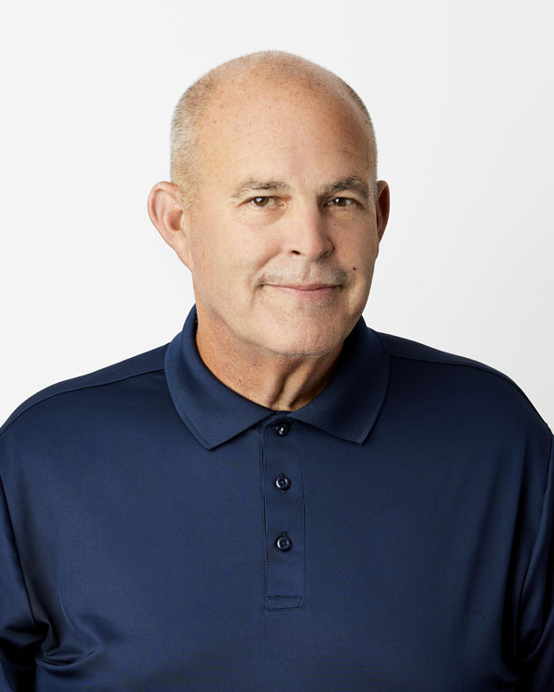
CU*Answers, the 100% credit union-owned cooperative CUSO, announced that it has completed its annual board planning session, held Aug. 30 – Sept. 1 in Lansing, West Virginia. During the planning session, the board finalized its CEO succession project with the announcement that it has selected current President/COO Geoff Johnson to replace Randy Karnes as CEO effective October 1, 2021.
Geoff Johnson
Randy Karnes
“Geoff has been an invaluable member of the CU*Answers team for many years, and we are confident that he will continue the legacy of exceptional leadership Randy leaves behind as he approaches retirement,” said Scott McFarland, CU*Answers’ Chairman of the Board and CEO of Honor Credit Union.
Johnson first joined CU*Answers in 2005, coming in with sixteen years in credit union leadership roles primarily overseeing lending. In 2014, he was named COO and further promoted to President/COO in 2018. During his tenure, Geoff has worked closely in the growth and development of CU*Answers Management Services teams including Earnings Edge, Lender*VP, AuditLink, Web Services, SettleMINT, and Imaging Solutions.
Speaking on the selection, Karnes said, “I have full faith in Geoff’s ability to guide CU*Answers forward in the years to come. His insight and work ethic have been a big part of the CUSO’s growth into new areas over the last decade. He has both the drive and the knowledge of our industry and organization to continue its forward momentum.” Karnes will continue with CU*Answers in an advisory and special projects role until his retirement September 30, 2022.
McFarland added that the board expressed its deep gratitude for the work Randy has done to advance CU*Answers, then WESCO, since first becoming CEO in 1994. “Randy never stopped at just a vision of what this CUSO could become—he worked tirelessly to see that vision come to pass. Above all, he’s always been invested in developing the strongest team possible, and he leaves a deep bench of robust leaders ready to carry the mantle, including our new CEO Geoff Johnson.”

About CU*Answers, Inc.
CU*Answers offers expertise in implementing technical solutions to operational needs, and is a leader in helping credit unions form strategic alliances and partnerships. CU*Answers provides a wide variety of services for credit unions including its flagship CU*BASE® processing system (online and in-house) and Internet development services featuring It’s Me 247 online and mobile banking. Additional services include web development, network design and security, and image check processing. Founded in 1970, CU*Answers is a 100% credit union-owned cooperative CUSO providing services to credit unions representing over 2 million members and $21.5 billion in credit union assets. For more information, visit www.cuanswers.com.

