Press Release
Canvas Credit Union shares warmth with local Denver restaurants

Canvas donates heaters to help local restaurants keep doors open and attract more diners

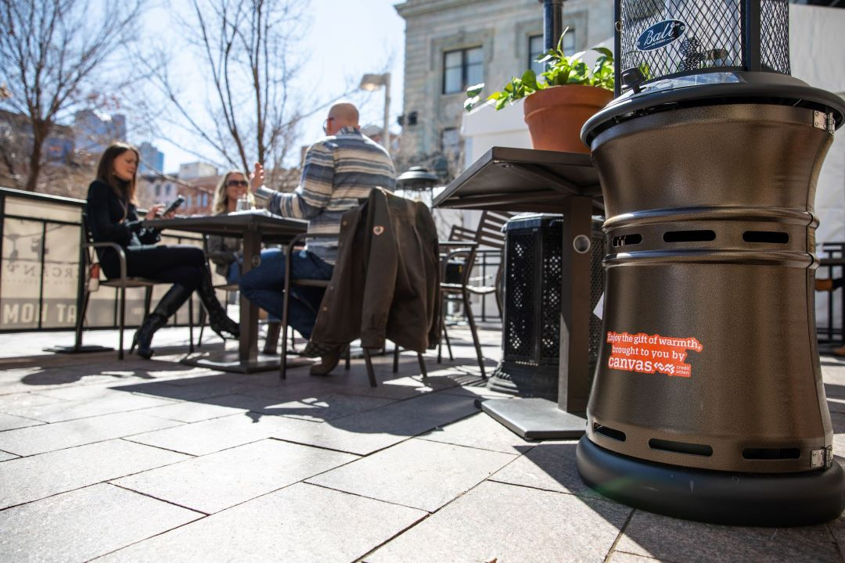
Heaters provide warmth to patrons dining outside at Mercantile in Downtown Denver.

LONE TREE, CO (March 8, 2021) — Now, more than ever, it is crucial to support local and small businesses. The food and beverage industry has been experiencing everchanging regulations throughout the pandemic, including carrying the financial burden to meet guidelines in order to keep their doors open. To show its commitment to its local communities and businesses Canvas Credit Union sought to provide warmth, figuratively and literally. Canvas partnered with Chef, Alex Seidel of Chook, Fruition, and Mercantile to provide heaters at their locations to allow for more patrons to visit these local restaurants safely and comfortably.
This time of uncertainty has not been easy on anyone, and many small businesses are struggling to stay afloat. Canvas wanted to support local businesses who also make an impact in the communities where they serve along the Front Range.
Canvas donated heaters that will allow local dining favorites to stay open, while adhering to COVID restrictions and increasing capacity by offering outdoor patio and heated tent seating. As winter and spring bring lower temperatures throughout the Front Range, restaurants are unable to fully house all their guests inside. Unsurprisingly, with outdoor heaters currently in high demand nation-wide, the cost has increased and created an extra burden and expense for many businesses.

Canvas provided a total of 15 heaters to Alex Seidel’s eateries:
- 6 at Mercantile, located in Downtown Denver’s Union Station
- 4 at Chook, located in Aurora at Stanley Marketplace
- 3 at Chook, located in Denver at 8th Ave & Birch St
- 2 at Fruition, located in Denver at E 6th Ave & N Marion St

Both Canvas and Alex Seidel share a passion for giving back to their communities while building long lasting relationships. Alex is consistently looking for ways to support his community who has supported him so well throughout his career. As a champion for food advocacy and mindfulness when it comes to eating habits and waste, becoming a chef and a business owner has allowed him to control the ingredients and the sourcing of his fare. Alex recently joined President & CEO Todd Marksberry in Canvas’ podcast, ‘In The Room w/ Todd Marksberry’, and explored his life-long journey with food and his commitment to giving back. “It’s not just about the plate of food, it’s also about the community,” shared Alex Seidel.

While the world looks forward to a time beyond the pandemic, Canvas will continue to lead with its heart and seek other ways they can help its communities. “We’re in a time that has created so many challenges, leading us to create new, unique ways to help our members and our Colorado community afford life,” shared Canvas President & CEO, Todd Marksberry. “Local businesses like Alex’s restaurants are what make our communities great, so we want to pay it forward. Afterall, we are all more impactful when our communities are healthy, engaged, and thriving.”

- - - - - - - - - - - - - - - - - - - - - - - - - - - -
About Canvas Credit Union (canvas.org)
Canvas Credit Union is a safe and insured financial institution with over $3 billion in assets and about 260,000 members. Canvas provides a full array of financial products and services, including savings, checking, loans, mortgages, and online and mobile options. Serving Colorado communities for more than 82 years, Canvas currently has 29 branches.
About Alex Seidel, Chef & Owner (mercantiledenver.com/our-story)
Alex Seidel is chef-owner of Fruition Restaurant, Mercantile dining & provision, Füdmill and Chook. Alex, Fruition and Mercantile have been fortunate to find themselves featured as Chef of the Year and Best Restaurant rankings in numerous local and national publications. Seidel himself has been the recipient of many accolades, including Food & Wine magazine’s Best New Chef in 2010, Chef of the Year titles from local media including Denver Magazine and 5280. Seidel was awarded the 2018 James Beard Foundation Best Chef: South West. Seidel participates in numerous off-site events for both charitable and fine dining experiences.

Contact Information
Tansley Stearns
Chief People & Strategy Officer
Canvas Credit Union
tansleys@canvas.org
Canvas Credit Union
9990 Park Meadows Drive
Lone Tree, CO 80124
United States of America

