Press Release
Shondra Houde of Canvas Credit Union becomes President of the Rocky Mountain Chapter of Mountain West Credit Union Association

From Treasurer to President, Shondra will lead the chapter to new heights of credit union advocacy
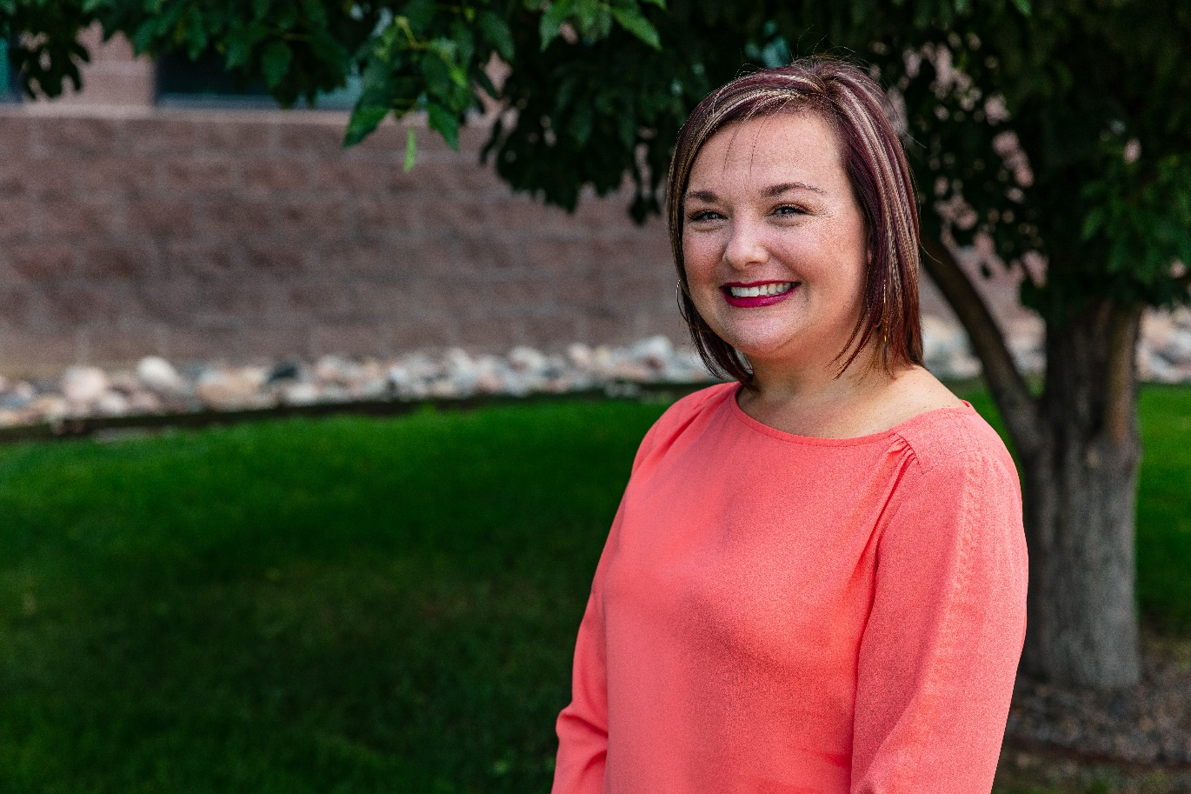

LONE TREE, CO (April 29, 2021) — Shondra Houde, Retail Director at Canvas Credit Union, has become the new President of the Rocky Mountain Chapter of Mountain West Credit Union Association (MWCUA). Shondra’s determination and passion for the credit union industry has led her from Treasurer to President, after joining the chapter over two years ago.
The Rocky Mountain Chapter of Credit Unions supports members from eight participating credit unions spanning from Boulder, CO to Cheyenne, WY. The mission of the Rocky Mountain Chapter of Credit Unions is to create value through education, credit union advocacy and elevated awareness for the members and staff across the Front Range.
As with most organizations, it is the people that make the Rocky Mountain Chapter a success. With a clear vision to help people thrive within the region, chapter members are recognized as leaders. They provide opportunities for growth and prosperity through collaboration, shared knowledge and professional development. The chapter board members give their time and talents, outside normal working hours, to create and host events throughout the year for the benefit of members, employees, the community and beyond. This includes professional development for employees, networking and social opportunities, community financial education through the Money Matters literacy series, and collaborative volunteer projects.
Canvas has been an active part of both the Mountain West Credit Union Association and the Rocky Mountain Chapter of Credit Unions for many years. One of Canvas’ strategic pillars is being known as a leader in the communities that they serve. Shondra demonstrates this pillar through her strong desire to build credit union collaboration through strong professional networks. As a Retail Director, Shondra guides the Canvas Family working at seven of Canvas’ branches throughout metro Denver to give members an outstanding branch experience. With an impressive tenure of over 16 years wholeheartedly serving our members, family and community, Canvas is thrilled to support Shondra’s personal growth and leadership across the chapter as she embarks as President of the Rocky Mountain Chapter.
“Representing the Rocky Mountain Chapter as their new president is such an honor,” shared Shondra Houde. “The collaboration with peers from credit unions across Colorado, brings invaluable insight and a great sense of camaraderie with our shared goal to collectively support and promote the credit union movement and exemplify people helping people. None of what we do in the Rocky Mountain Chapter is possible without the ongoing commitment of our board members and the support of our credit union leadership. As President, I am excited to help our industry thrive as we work together to continue bringing this commitment to life.”
- - - - - - - - - - - - - - - - - - - - - - - - - - - -
About Canvas Credit Union (canvas.org)
Canvas Credit Union is a safe and insured financial institution with over $3 billion in assets and about 260,000 members. Canvas provides a full array of financial products and services, including savings, checking, loans, mortgages, and online and mobile options. Serving Colorado communities for more than 82 years, Canvas currently has 29 branches.
About Mountain West Credit Union Association Chapters (mwcua.com/about/chapters)
The Mountain West Credit Union Association’s (MWCUA) 12 individual chapters each represent credit unions located within designated geographic boundaries of Arizona, Colorado, and Wyoming. The Association’s chapter program promotes unity among credit unions in a local area through communication, networking, training, and participation in community, state, and national projects that support the cooperative spirit of the credit union movement.

Contact Information
Tansley Stearns
Chief People & Strategy Officer
Canvas Credit Union
tansleys@canvas.org
Canvas Credit Union
9990 Park Meadows Drive
Lone Tree, CO 80124
United States of America

