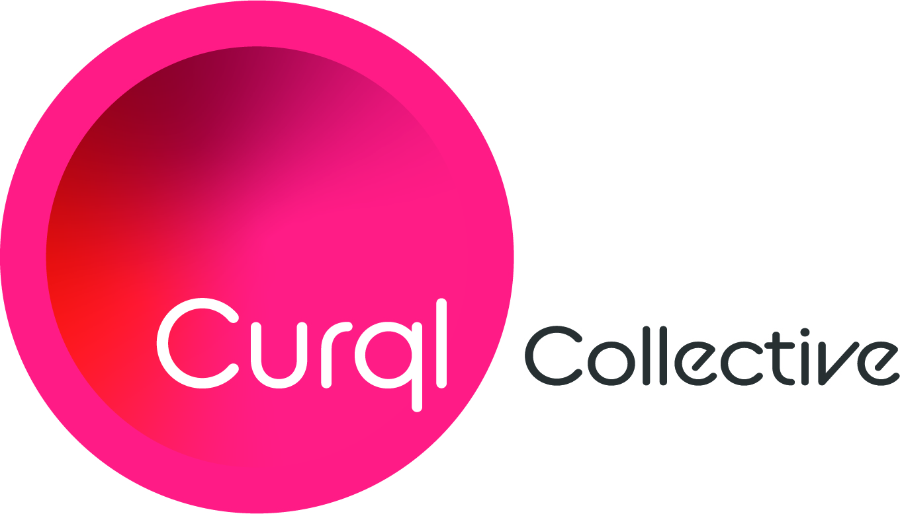
Media Contact:
Merideth Miller, M2 The Agency
281.882.3045
pr@m2theagency.com

For Immediate Release: First Close Announced for $150 Million Venture Capital Fund ‘Curql’

(Des Moines, Iowa) — Curql Collective’s flagship Curql Fund I announced its first fundraising close on April 6, 2021, reaching an initial fundraising goal in excess of $70M. Created and launched to the industry by the collaborative innovation at Members Development Company (MDC), Curql Fund I is the only VC fund of its kind – serving as a gateway for FinTech access to credit unions.

Brian E. Wolfburg, President and CEO of VyStar Credit Union, one of Curql’s early investors, notes, "VyStar is committed to investing in innovation through technology to keep our organization on the leading edge of member experience, so the investment was a natural fit. The speed at which Curql completed this first round of fundraising speaks volumes to the credit union industry's commitment to ensuring our relevance in an ever-changing space."

Investors committed during the first round of fundraising include Affinity Plus FCU, Alloya Corporate Federal Credit Union, Altra FCU, Campus USA CU, Coastal Credit Union, Community First Credit Union (Florida), Co-Op Financial Services, Desert Financial Credit Union, Educators Credit Union, Evansville Teachers Federal Credit Union, Georgia’s Own Credit Union, Hudson Valley Credit Union, IH Mississippi Valley Credit Union, Meritrust Credit Union, Michigan State University Federal Credit Union, New England Federal Credit Union, SchoolsFirst Federal Credit Union, Sound Credit Union, Suncoast Credit Union, TDECU, UNIFY Financial Credit Union, USE Credit Union, Veridian Credit Union, VyStar Credit Union, and Y-12 Federal Credit Union.

As the fund moves into the next round of fundraising, MDC President and CEO Jeff Kline commented, “While the idea of Curql began with a team of MDC credit unions, we’re excited to onboard investors across our industry who are interested in making real change that impacts how organizations engage with their members, and how members engage with their money. We're opening the door for credit unions to make an impact and for FinTech companies to access a wide range of new customers.”

About Curql

Curql is a collaborative approach to venture capital launched in 2020 by the progressive, industry-leading credit unions of Members Development Company (MDC) and is steered by a collective of former founders, operators, and leaders in the FinTech and VC spaces. The group's flagship – Curql Fund I – invests in the visions of entrepreneurs who thoughtfully and purposefully develop financial services technology that revolutionizes and innovates how people engage with their money.

Curql Fund I is managed by Next Level Ventures, the largest investment firm managing credit union assets today. The Next Level team has over 50 years of collective experience in supporting the remarkable people leading the way in innovative technology development.

-###-

