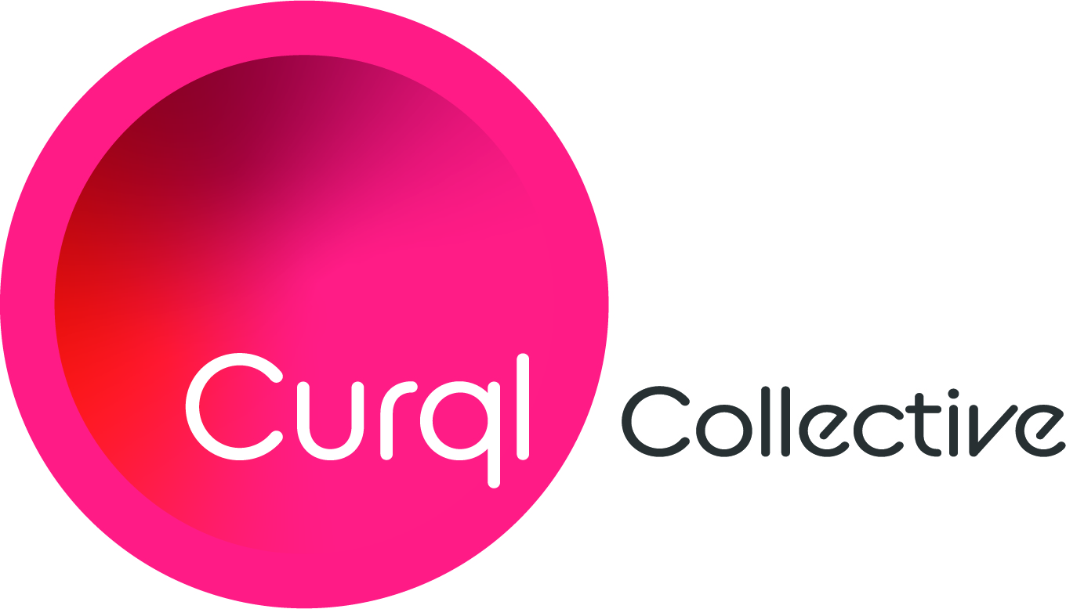
Media Contact:
Merideth Miller, M2 The Agency
281.882.3045
pr@m2theagency.com

For Immediate Release: $150 Million Venture Capital Fund ‘Curql’ Announces Open Access to Credit Union Investors

(Des Moines, Iowa) — Curql Collective (curql.com) is announcing the availability of investment opportunities in the group’s flagship – Curql Fund I. The fund was created and launched to the industry after recognizing the need to make a serious commitment to technology to ensure continued growth and stability for the credit union industry. The only fund of its kind, Curql offers a key competitive advantage as the gateway for fintech access to credit unions – and the only gateway that can deploy money at the speed of a VC. The fund recently announced its first close on April 6th, reaching an initial fundraising goal in excess of $70M.

Michigan State University Federal Credit Union was an early investor in the fund. President & CEO April Clobes commented, “MSU Federal Credit Union is pleased to participate in Curql Fund I. The fund creates opportunities for credit unions to collaboratively make investments in fintechs to enhance our members’ experiences. By partnering with fintech, we can provide robust digital services and remain competitive in the financial services industry.”

The fund is managed by the team at Next Level Ventures (NLV), the largest investment firm managing credit union assets. NLV Managing Partner Craig Ibsen noted, “We are very pleased to be ahead of our fundraising goals. The simple fact that this fund was created and credit unions are coming to the table as investors at a faster pace than we anticipated is a clear indication of the importance the industry is placing on technology and ensuring opportunities for continued growth and stability in a competitive landscape."

To date, NLV has onboarded 25 investors and looks forward to welcoming additional investors as they enter this next phase in fundraising. Credit unions seeking investment opportunities in Curql Fund I should contact Craig Ibsen of NLV at (515) 369 -2600 or email at info@nextlevelvc.com.

About Curql

Curql is a collaborative approach to venture capital launched in 2020 by the progressive, industry-leading credit unions of Members Development Company (MDC) and is steered by a collective of former founders, operators, and leaders in the fintech and VC spaces. The group's flagship – Curql Fund I – invests in the visions of entrepreneurs who thoughtfully and purposefully develop financial services technology that revolutionizes and innovates how people engage with their money.

Curql Fund I is managed by Next Level Ventures, the largest investment firm managing credit union assets today. The Next Level team has over 50 years of collective experience in supporting the remarkable people leading the way in innovative technology development.

-###-

