For Immediate Release: Friday, February 25, 2022
For More Information: Victoria Taylor, AVP, Marketing, Callahan & Associates, vtaylor@callahan.com
Credit Unions See Record High Member Engagement and Relationships In 4Q21, Showing That American Consumers Continue to Choose Cooperatives To Meet Their Financial Goals
WASHINGTON, DC – More consumers than ever turned to credit unions in 2021. Total industry assets surpassed $2 trillion last year, as over 5.4 million Americans became new credit union members bringing total membership to 131.1 million. Additionally, the industry is seeing accelerated growth in key metrics, including total members, account penetration, and total member relationship.
Callahan & Associates shared industry data from the fourth quarter of 2021 last week during its quarterly Trendwatch webinar.
“Credit unions are a people-driven business,” Callahan’s President and CEO, Jon Jeffreys, said during the event. “It’s about the members. That’s what we’re here for. That’s how we measure success.”
Credit unions continue to differentiate themselves with an emphasis on being purpose-driven. More credit unions are taking a value-based banking approach, exemplified by Clearwater Federal Credit Union ($854M, Missoula, MT) and its president and CEO, Jack Lawson.
“This is how credit unions differentiate themselves,” said Lawson during Trendwatch. “This is how we get people to stand up and take notice. It’s about members. It’s about impact. It’s about helping communities.”
American Consumers Turn To Credit Unions To Reach Their Financial Goals
Membership grew 4.3%, annually, to 131.1 million total members as of December 31, 2021. Both average member relationship and share draft penetration hit record highs at $22,534 per member and 61.2% respectively.
Cooperatives are finally seeing the effects of pandemic-era government stimulus begin to smooth out and find equilibrium.
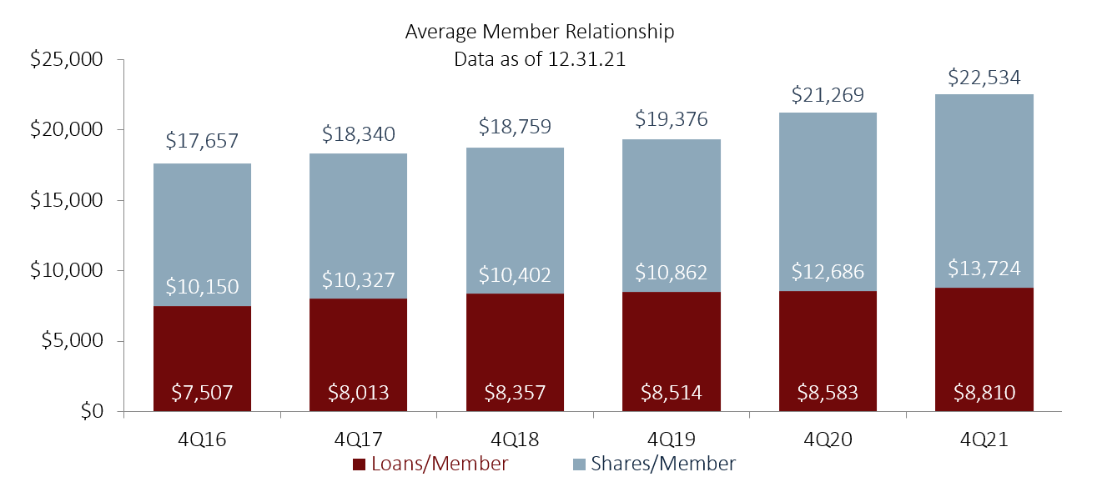
Data Source: Callahan & Associates
In Another Record Year For Credit Union Lending, Consumer Lending Leads Origination Growth
Credit unions saw growth in all key lending categories. Originations reached a record high, growing 17.2% annually to $795 billion as of December 31. Consumer lending led originations, growing 21.8% annually to a total of $386.5 billion.

Driven by rising home prices, first Mortgage dollar originations grew 7.5% annually to 313.7 billion during the year.
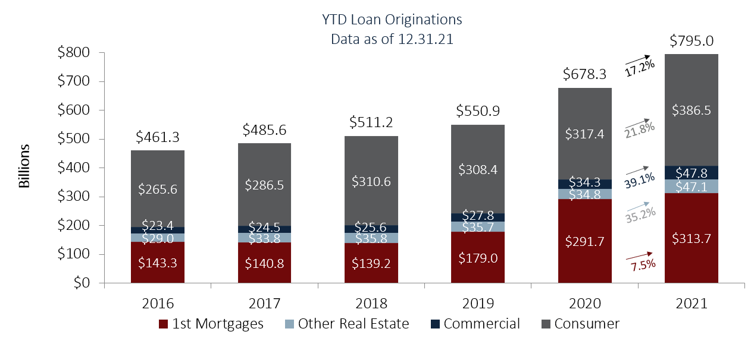

Data Source: Callahan & Associates
“On the balance sheet, loan growth accelerated during the year as originations outpace early paydowns,” said Callahan industry analyst, Will Hunt. “Excess liquidity is converting into balance sheet loans at a faster rate than we’ve been seeing and borrowing demand is high among members. Credit unions are there to meet that need.”
Historically High Earnings Can Fund Capitalization and Member-Experience Initiatives
Capitalization continued to be a hot topic for credit union leaders, given the new regulatory requirements from the NCUA. Still, the industry at large is well-capitalized, but earnings are historically high – industry ROA reached 1.06% though 2021. Total industry net worth continued to grow as a result; up 11.2% to 214.1 billion at the end of 2021. The aggregate credit union net worth ratio remained healthy at 10.3% of assets.
The upcoming changes pose a potential confounding factor. Many credit unions might opt to hold onto excess capital, at least during the transitionary period between the old and new reporting standards.
“It will be up to credit union leaders to balance their capital usage effectively across their obligations to both their regulators and their member-owners,” said Hunt. “The ongoing question is how are credit unions going to utilize these earnings to further support members while also balancing regulatory capitalization requirements.”
For more industry data, read Callahan’s 5 Takeaways From Trendwatch or watch the webinar recording on CreditUnions.com.
Callahan credit union clients can access industry data via Peer-to-Peer, CUAnalyzer, and Peer+ on their client portal. Non-clients can request a custom data scorecard here.
About Callahan & Associates
For more than 35 years, Callahan & Associates has helped credit union leaders identify strategic growth opportunities that increase member value. We create meaningful dialogue, connect people, provide counsel, and help organizations thrive through our competitive analytics, best-practice media, leadership consulting, and collaborative ventures. Our clients grow assets, members, shares, and loans faster than industry averages. Learn more at www.callahan.com.

