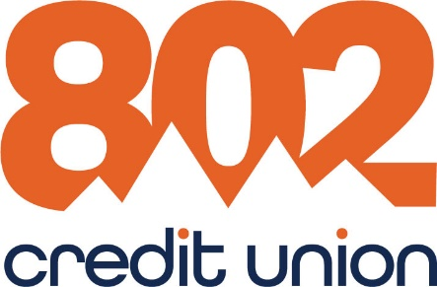
Contact: Lori Crowley, VP, Marketing | 50 White Street
p: 802.861.4572 | South Burlington, VT 05403
e: lcrowley@802cu.com | 802cu.com

PRESS RELEASE – For release on or after Thursday, October 21, 2021
802 Credit Union donates to everybody wins! vermont in honor of international credit union day
Barre, VT – On October 21, 2021, 802 Credit Union will join over 56,000 credit unions around the world to celebrate International Credit Union (ICU) Day. In honor of this day, 802 Credit Union is donating $1000.00 to Everybody Wins! Vermont.
International Credit Union Day highlights the many ways that credit unions across the world help members improve their financial health and well-being and is celebrated each year on the third Thursday in October.
“Credit Unions exist not only to benefit our membership but also the communities that we serve. That’s why we are proud to make this donation highlighting the great contributions that credit unions like ours make to support everyone in our field of membership.”, explains CEO Sean Gammon.
Everybody Wins! Vermont is a literacy-based mentoring program that increases children’s prospects for success and engages a diverse range of volunteers in their community schools. Based out of Montpelier, the program is available in 25 schools in Vermont and one in New Hampshire.
802 Credit Union is a $350 million-plus financial institution, with nine locations currently serving over 33,000 members. Members are part of a cooperative, meaning they share ownership in the Credit Union and elect a volunteer board of directors. 802 Credit Union provides membership to anyone who lives, works or worships in Vermont as well as Grafton, Sullivan and Cheshire counties in New Hampshire. For more information about 802 Credit Union visit 802cu.com.

Page 1 of 1

