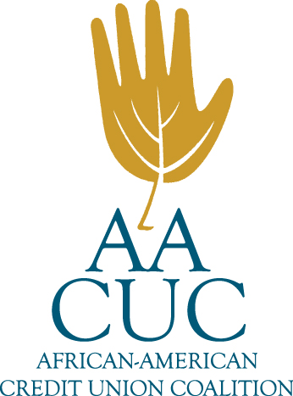

CO-OP FORMALIZES LONG-STANDING SUPPORT OF
AFRICAN-AMERICAN CREDIT UNION COALITION WITH NEW PARTNERSHIP

Corporate Partnership Furthers CO-OP’s Contribution to the Strength of the Credit Union Movement

For Release on July 13, 2021:

RANCHO CUCAMONGA, California, and SNELLVILLE, Georgia – Credit union payments fintech CO-OP Financial Services today announced an expansion of its support for the African-American Credit Union Coalition (AACUC) by committing to a five-year corporate sponsorship.

Through this long-term commitment, CO-OP will work with the AACUC to help develop, promote and participate in the Coalition’s events and initiatives, including its Annual Virtual Conference, planned for August 16-21.

“There is strong cultural alignment between the AACUC and CO-OP, as both organizations are grounded by a purpose to strengthen the credit union industry,” said Dorthy Mack, Diversity, Equity & Inclusion Council Co-chair at CO-OP. “Watching the AACUC’s growth has been exciting; it’s a testament to the movement’s acknowledgement of the need for change and AACUC’s tenacity to lead the way. CO-OP is honored to join AACUC leadership, members and supporters in the unification, education, conversations and investments that will bring the movement closer to a future in which diversity, equity and inclusion thrive.”

CO-OP’s own DE&I Council serves as a forum for conversation within the company. The Council works to foster a workplace where every employee feels valued, respected and connected. Recently the Council invited employees to form Engagement Resource Groups based on employees’ shared characteristics, life experiences and interests. Mack anticipates the Council’s work will dovetail well with the activities of the AACUC, enabling a highly engaging partnership.

“We look forward to deepening our collaboration with CO-OP team members who are clearly eager to partner in bringing about meaningful change,” said Renee Sattiewhite, President/CEO of the AACUC. “This is a crucial time for all people, and especially those in a position of strength and influence, to fight against racism in all forms. CO-OP has a significant opportunity to make a lasting difference in the lives and careers of the people helping millions of Americans live financially healthy lives.”

About CO-OP Financial Services
CO-OP Financial Services is a payments and financial technology company whose mission is ensuring the success of the credit union movement. CO-OP payments solutions, engagement services and strategic counsel help credit unions optimize member experiences to consistently provide seamless, personalized multi-channel offerings, while delivering secure, sophisticated fraud mitigation service. For more information, visit www.coop.org.

About African-American Credit Union Coalition

The AACUC is a 501c3 non-profit organization created in 1999 to increase the strength of the global credit union community through professional development and advocacy. It has become an all-encompassing organization for individuals (professional and volunteers) in Credit Unions, Insurance, Regulators, Consultants and other entities in the credit union industry. AACUC is considered a leader in the credit union industry adopting the 8th Cooperative Principle and providing knowledge of how credit unions can become more diverse and inclusive. For more information, visit https://www.aacuc.org.

Contact: Bill Prichard, APR Laila Lauson
Director, Public Relations Media Director
CO-OP Financial Services African-American Credit Union Coalition
(909) 532-9416 (770) 761-2769
Bill.Prichard@coop.org llauson@aacuc.org
-####-

