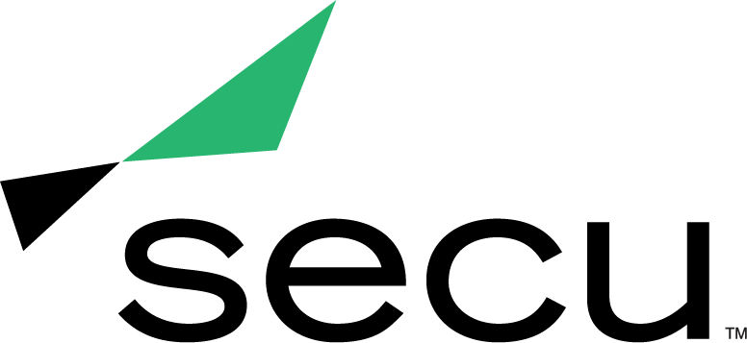
News Release

Becky Smith Presented with American Advertising Federation of Baltimore Silver Medal Award
The Award Honors Smith’s Excellence and Contributions to the Advertising Industry

Baltimore, Md. (March 8, 2021) — Becky Smith, Executive Vice President of Marketing and Strategy for SECU - Maryland’s largest state chartered credit union - was awarded the Silver Medal Award from the American Advertising Federation of Baltimore (AAFB), an organization dedicated to promoting and supporting Baltimore’s thriving advertising community.

The Silver Medal Award recognizes a leader who has made outstanding contributions to advertising and who has been active in furthering the industry’s standards, creative excellence and responsibility in areas of social concern. The AAFB presented the Silver Medal Award to Smith at the 2021 American Advertising Awards (the ADDYs) on March 4, which was held as a live virtual event this year.

“Becky stood out to the AAFB nomination committee, not only for her amazing career accomplishments, but also her dedication to her team at SECU, to the industry and the Baltimore community,” said Courtney Black, AAFB President and Senior Account Executive at GKV.

Smith has more than 20 years of integrated marketing leadership experience with specific expertise in guiding companies and brands through transformative advertising and marketing efforts.

Since joining SECU in 2019, Smith has propelled the credit union’s reputation as a reliable, member-centric brand that sets new standards for innovative products and experiences. As the Executive Vice President of Marketing and Strategy for SECU, she has executed long-term plans and initiatives focused on marketing, advertising, corporate communications, member experience, community outreach, and digital and business intelligence. Smith has also built and led world-class marketing, strategy, digital and innovation teams to achieve SECU’s brand and financial objectives, including the launch of SECU’s brand refresh, the opening of SECU's first new financial center in several years, and the introduction of SECU’s virtual financial center experience.

“Becky’s leadership and creative vision has not only transformed SECU’s advertising, marketing and business strategy, but serves to empower those around her to act as change agents,” said Dave Sweiderk, President and CEO for SECU. “Her drive for bold change extends to the larger Maryland community. It’s wonderful to see her achievements recognized by the American Advertising Federation of Baltimore.”

As the Executive Director of the SECU MD Foundation, Smith has also leveraged her marketing experience to become an active member of the community and create a positive impact across Maryland. In addition to growing the Foundation’s existing programs, such as its Scholarship Program and support for the Maryland Food Bank and Kennedy Krieger Institute, Smith has had a critical role in identifying and developing initiatives during times of need. In response to the COVID-19 pandemic, Smith spearheaded the launch of the SECU MD Foundation Relief Fund, which provided more than $215K in grants to individuals and nonprofits experiencing hardships. In 2020, she also led SECU's first-ever Day of Kindness, inspiring the SECU team to perform nearly 7,000 random acts of kindness and raising more than $51K in donations to support education, health and wellness, and community development initiatives.

Learn more about the AAFB and view the complete list of 2021 ADDY winners by visiting Baltimoreadvertising.com.

About SECU (State Employees’ Credit Union of Maryland)
SECU ("see-Q"), Maryland’s largest state chartered credit union, serves 260,000 members across the state. As a member-owned, not-for-profit, SECU puts its members first. Membership is open to all Maryland state employees and their families, University System of Maryland students, graduates, staff and their families, Bank At Work partners and many others. Headquartered in Linthicum, Md., SECU has 22 financial centers and provides access to 30,000 free ATMs through the CO-OP network. With more than $4 billion in assets, SECU ranks among the top 60 credit unions nationwide based on total assets in the U.S. Insured by NCUA. For more information, visit www.secumd.org or follow SECU on Twitter, Facebook and Instagram.

About the American Advertising Federation of Baltimore
Founded in 1920, the American Advertising Federation of Baltimore (AAFB) connects, educates, and advocates for thousands of communications professionals in advertising, marketing, business, tech, education, and law. It is a 501(c)(6) non-profit and a chapter of the American Advertising Federation which includes 200 local clubs across the U.S. representing nearly 40,000 advertising professionals. Visit Baltimoreadvertising.com to learn more.

###

Media Contact
Kelly Nguyen
knguyen@planitagency.com
609-385-6701

