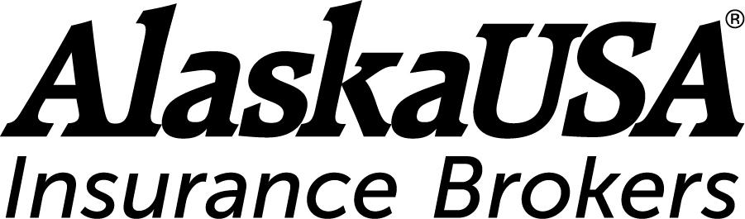

FOR IMMEDIATE RELEASE

[Date]

Media Contacts
Dan McCue
Senior Vice President, Corporate Relations
Alaska USA Federal Credit Union
907-786-2807
D.McCue@alaskausa.org

Brooke Niemeyer
Associate Director of Media Relations
Policygenius
brooke.niemeyer@policygenius.com

Policygenius and Alaska USA Insurance Brokers Collaborate on Financial Protection

Anchorage, Alaska – Alaska USA Insurance Brokers and Policygenius announced today a new collaboration to offer life insurance fulfillment to Alaska USA customers through the Policygenius online platform. The collaboration enhances the already exceptional variety of services that clients have come to expect from Alaska USA Insurance Brokers.

Policygenius has placed more than $120 billion in coverage and is one of the largest term life insurance broker platforms in the United States. Alaska USA Insurance Brokers is a subsidiary of Alaska USA Federal Credit Union, a prominent credit union with more than 700,000 members worldwide. Alaska USA chose to partner with Policygenius due to its top-tier platform, accelerated life insurance product offerings, and ability to help people save on insurance through comparing quotes.

“Alaska USA Insurance Brokers and Policygenius share a number of values that make us a good fit, including a commitment to the financial wellbeing of our clients and an emphasis on having a fully informed client base,” said Julia Niziolek, President, Alaska USA Insurance Brokers. “Life insurance is vital to a comprehensive financial plan. Those who are just getting started on their financial journey, or who have been earning and saving money for a while, deserve to have excellent life insurance options to protect their loved ones and assets.”

“We’re committed to helping people get the financial protection they need to protect themselves and their families,” said Jennifer Fitzgerald, CEO and co-founder of Policygenius. “We’re happy to support Alaska USA in providing life insurance to their membership base.”

The Alaska USA Insurance Brokers and Policygenius collaboration began with a soft launch earlier in 2021. By collaborating with Policygenius, Alaska USA is expanding the scope of financial services it introduces to its members.

-more-

About Policygenius

Policygenius transforms the insurance journey for today’s consumer, providing a one-stop platform where customers can compare options from top insurance carriers, get unbiased expert advice, buy policies, and manage their insurance portfolio, in one seamless, integrated experience. Our proprietary technology platform integrates with the leading life, disability, and home and auto insurance carriers and delivers an exceptional digital experience for both consumers and insurance carriers. Since 2014, our content, digital tools, and experts have served as a resource for millions of people on their insurance journey, and we have sold more than $120 billion in coverage. To receive Policygenius announcements, email press@policygenius.com. Subscribe to the Easy Money by Policygenius newsletter here.

About Alaska USA Insurance Brokers

Alaska USA Insurance Brokers was established in 1986 as a subsidiary of Alaska USA Federal Credit Union. With a staff of nearly 40 insurance professionals, it provides personal insurance for approximately 17,000 individual clients. Alaska USA Insurance Brokers has offices in Anchorage, Fairbanks, Homer, Juneau, Soldotna, and Wasilla, Alaska, and Glendale, Arizona, as well as in Renton and Tacoma, Washington.

Learn more at alaskausa.org/insurance.

