
FOR IMMEDIATE RELEASE For more information, contact
Sharon Simpson, 240.620.4095

ECTC, Abound Credit Union Partner to Launch Military Education Association

RADCLIFF, Ky. (February 9, 2021) – Elizabethtown Community & Technical College’s Military Education Association (MEA), sponsored by Abound Credit Union, is an exciting new opportunity to support the college’s nearly 400 military and veteran students.

Recently launched in 2020, Abound has already donated approximately $3,600 through the MEA and has lofty goals for expanding the financial support available for military and veteran students through this partnership in 2021 and beyond. The MEA will fill important gaps in existing aid programs and provide ECTC with greater flexibility by funding textbooks, instructional supplies, and career readiness training along with other tailored services and programs.
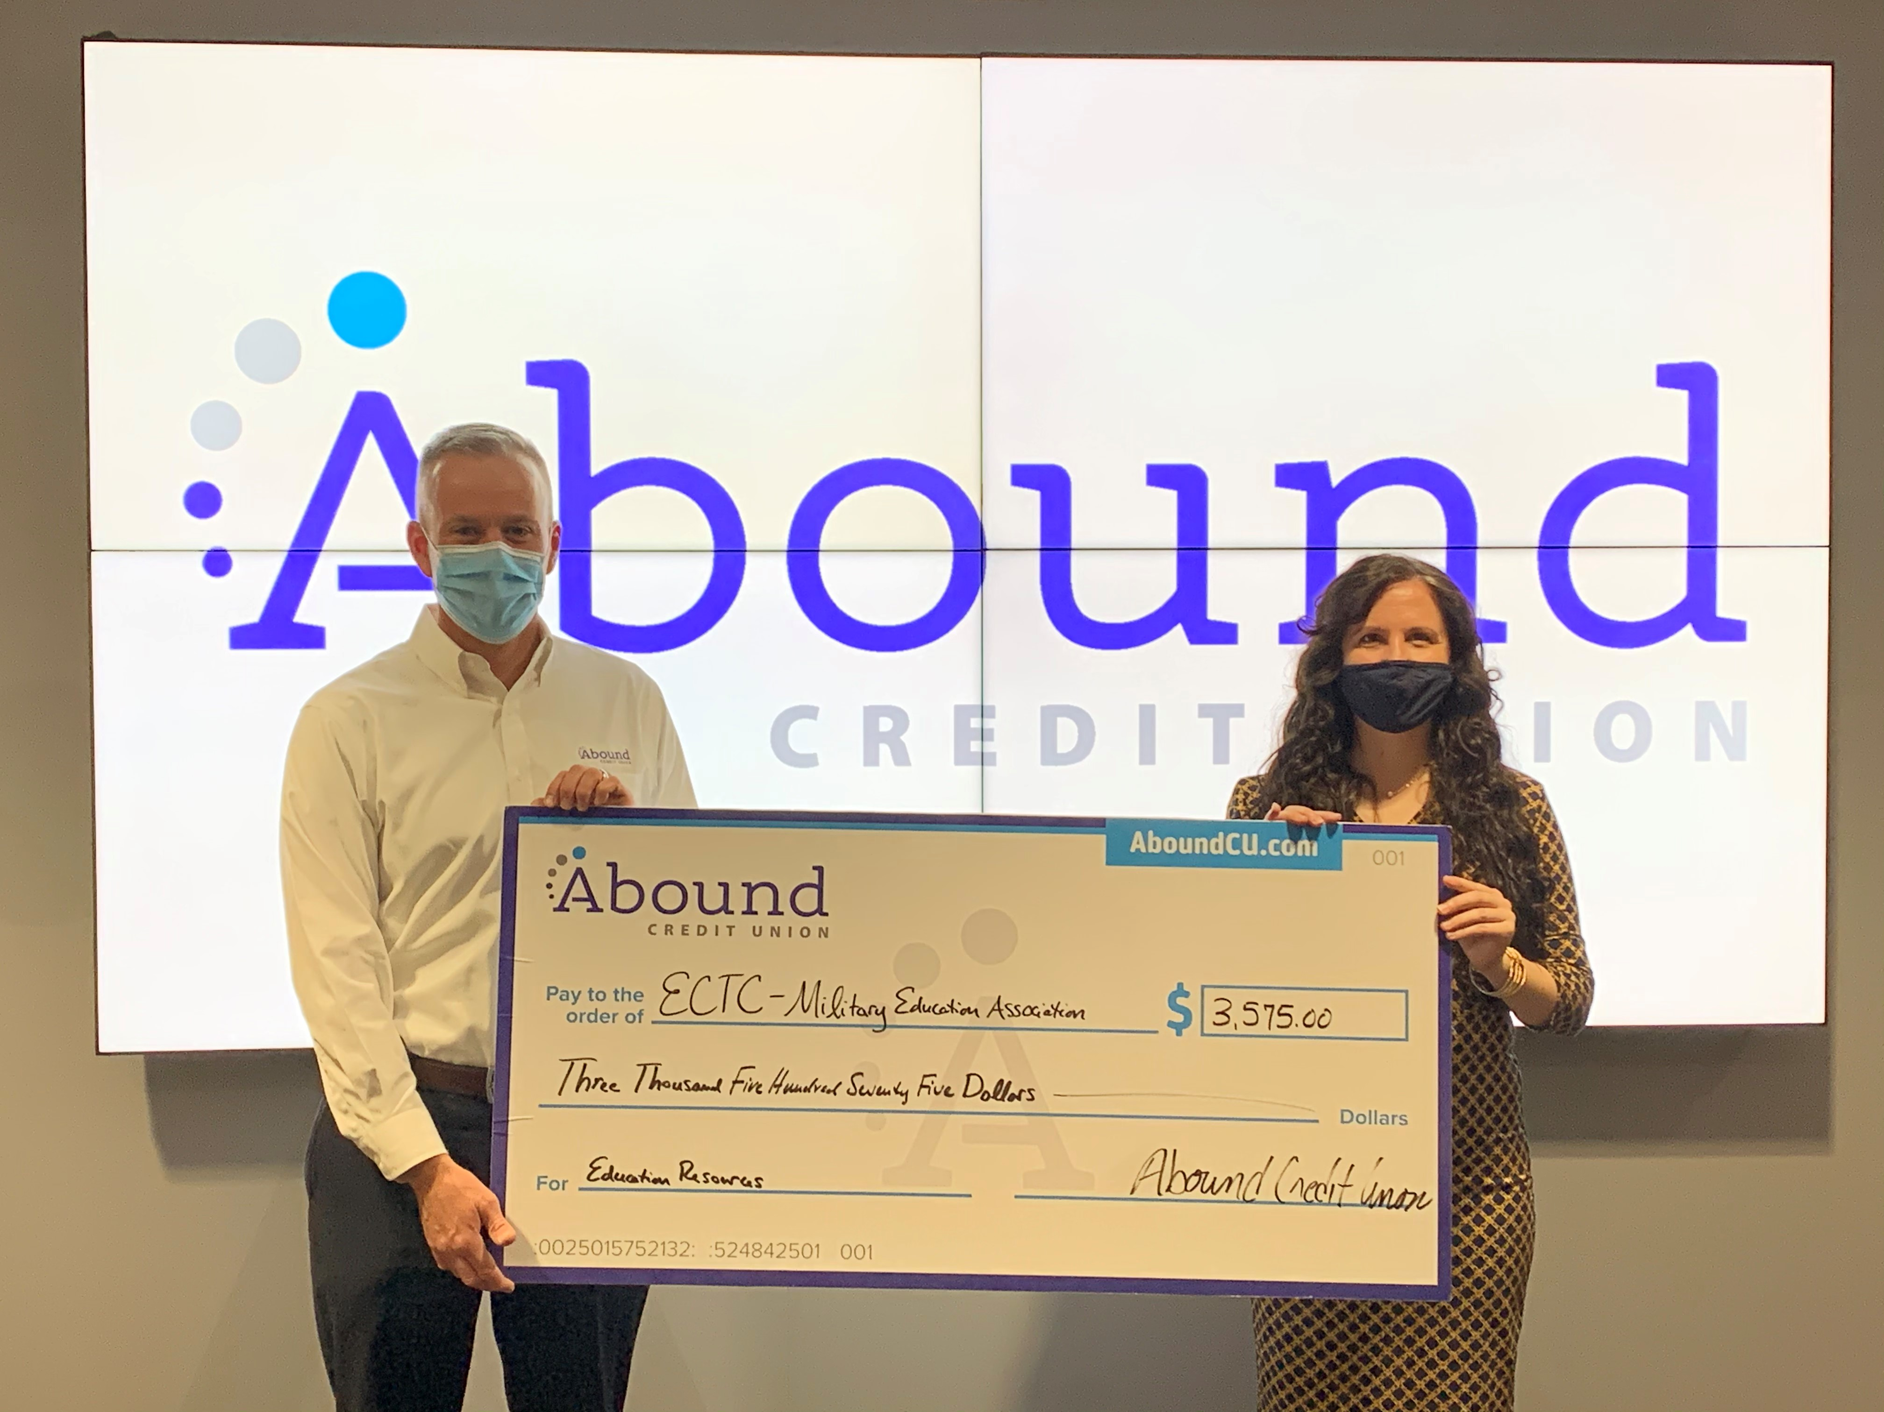

“The ongoing support of Abound Credit Union helps us make success possible for our military and veteran students,” says Megan Stith, CFRE, Chief Institutional Advancement Officer for ECTC. “We look forward to accomplishing even more together in 2021 and beyond through the Military Education Association.”

Individuals interested in supporting ECTC’s military and veteran students are invited to join the MEA. Members will receive invitations to special events, regular updates on ECTC news, and reports on how their support impacts the lives of students. The membership fee is $12.50 for the first year and $25 for future years. More information and instructions on how to join are available online at https://elizabethtown.kctcs.edu/alumni/giving/military-education-association.aspx

“Our partnership with ECTC is so important. Not only are we advancing education and preparing young adults for future success, we’re also able to join forces to support our military and veteran students,” says Ray Springsteen, President/CEO of Abound Credit Union. “At Abound, we’re always focused on making more possible for our community.”

In addition to Abound’s community partnerships, free online learning tools and financial education resources for Kentuckians of all ages are available at www.aboundcu.com.

About Abound Credit Union
Abound Credit Union has been providing valuable banking solutions to help hardworking Kentucky families thrive for 70 years. Today, we’ve grown to become Kentucky’s largest credit union with 18 locations, $1.8 billion in assets and over 110,000 military and civilian members. The Credit Union has been recognized for its leadership in financial education at the state and national level, winning the 2020 KY Governor's Service Award and a 2019 Credit Union National Association Award for Youth Financial Literacy. Abound Credit Union is also proud to be one of the Best Places to Work in Kentucky. It’s simple to become a Member, visit our website at www.AboundCU.com to see how you may be eligible.
###

