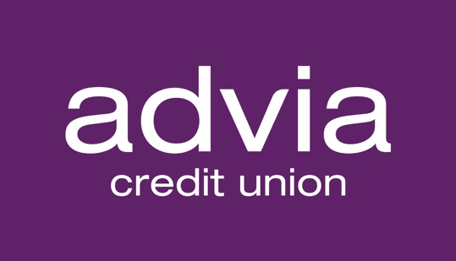

Advia Credit Union Celebrates Milestone of $75M
in Cost Savings for Members

KALAMAZOO, Michigan, March 2, 2022 – Advia Credit Union announced that it has passed a milestone of $75 million in cumulative savings for its members through its popular Half-Off Loan Transfer program, established in 2007 and offered annually since.

Advia’s Half-Off Loan Transfer program allows members to transfer existing loans to Advia from other financial institutions and save up to half off their transferred loan rate, as low as Advia’s lowest advertised rate. Advia typically saves members an average of $3,000 over the life of their transferred loan(s). In 2021, the cumulative amount saved for members was Advia’s highest one-year total yet — over $12 million. For more information about the program, visit adviacu.org/hot.

“At Advia, we’re proud to be known for our Half-Off Loan Transfer program because it’s an excellent example of us fulfilling our mission to provide financial advantages for our members,” said Cheryl DeBoer, CEO of Advia. “Reaching $75 million in cumulative savings for our members is quite an accomplishment, and we don’t intend to stop there. We’ve already hit the road in 2022 offering this program and are looking forward to even greater milestones in the future.”

According to Experian, 34% of consumers currently pay higher rates on loans due to having credit scores below 670. Higher rates can happen for several reasons, including a history of late payments or a person’s current revolving credit balance in comparison to their total credit limit. According to a survey co-sponsored by the Consumer Federation of America, an estimated 25% of low-income consumers do not know how to improve their credit scores — a crucial prerequisite for qualifying for a rewritten loan in the future.

As a CDFI (Community Development Financial Institution), Advia is dedicated to serving individuals with below-median incomes. A central part of this responsibility is credit health education. Advia’s member service representatives advise members on steps to improve and maintain their credit scores and explain the long-term benefits of doing so.

“When helping members transfer loans, our member service team takes it as an opportunity to help members understand the critical factors in establishing and maintaining good credit,” DeBoer said. “We pride ourselves on the meaningful relationships we build with our members, and we have an ever-growing list of success stories where members were able to qualify for reduced loan payments saving them thousands of dollars.”

In one recent example, Advia Member Service Specialist April Bolser was able to help a member transfer five loans from other financial institutions.

“I was so excited to be able to reduce the interest rates they were paying and lower their monthly payments, freeing up over $1,400 each month for the member,” Bolser said.

Advia’s member service specialists act as advocates for members, helping them save money and identify ways to help improve their financial lives overall. This process often begins by reviewing the member’s credit report, with their consent.

“It’s not unusual to find unsecured credit card debt and other bills that exceed $30,000. In many cases, we’re able to discover higher-rate loans that began years ago,” Bolser said. “In the meantime, the individual has built stronger credit or have had other factors change in their lives that allows us to re-write the loan to a substantially lower rate.”

Members typically use the Half-Off Transfer Program to transfer auto loans, personal unsecured debt, and credit card balances. Some types of loans are excluded from the offer, such as transferred mortgage loans or moving a loan to a home equity line of credit.

Advia’s team uses a special tracking calculator for illustrative purposes to document each member’s estimated savings on a transferred loan. Members may choose to add more to their loan over time, or pay it off early, which can further adjust their savings.

About Advia Credit Union
Advia Credit Union’s mission is to provide financial advantages to its members. With over $2.6 billion in assets, Advia seeks to provide quick and easy access to money and time-saving financial tools to nearly 190,000 members in Michigan, Wisconsin, and Illinois. Advia’s team of over 500 professionals delivers excellent service and innovative products at 29 locations and via digital and mobile platforms. Advia is guided by its core values: driving progress, acting with integrity, building, and strengthening relationships, and keeping people at the core. Visit adviacu.org to learn more about how Advia provides Real Advantages for Real People™.

