FOR IMMEDIATE RELEASE
September 22, 2021

Alaska USA Foundation donates $15,000 to Big Brothers Big Sisters of Alaska

Anchorage, Alaska – The Alaska USA Foundation is committed to supporting organizations that help provide much needed services in the communities we serve. For more than 17 years, the Foundation has been supporting nonprofits focused on helping children, veterans, and active-duty military personnel and their families.

Recently, the Alaska USA Foundation donated $15,000 to Big Brothers Big Sisters of Alaska in support of their military program. This program provides support to children of military families, working to pair a member of the military or a veteran with a military child. This provides a level of understanding and some added compassion, along with a much-needed adult mentor. Children of military families are often dealing with frequent changes to their family life as well as potential separation, loss, or just added day-to-day stress.

“The Alaska USA Foundation is a long-time supporter of Big Brothers Big Sisters of Alaska,” said Dan McCue, Executive Director, Alaska USA Foundation. “The military program does a great job of providing an incredibly valuable service to military families and, in particular, military children. Additionally, it allows for service men and women as well as veterans to give back to their own community.”

More About Alaska USA Foundation

For more than fifteen years, the Alaska USA Foundation has supported 501(c)(3) charitable organizations that provide needs-based services to children, veterans, and active-duty members of the military and their families. Since its inception, the Foundation has distributed more than $3 million to these organizations and is honored to assist those that provide direct services in support of its mission. Additional information about the Alaska USA Foundation is available at alaskausafoundation.org.

-more-

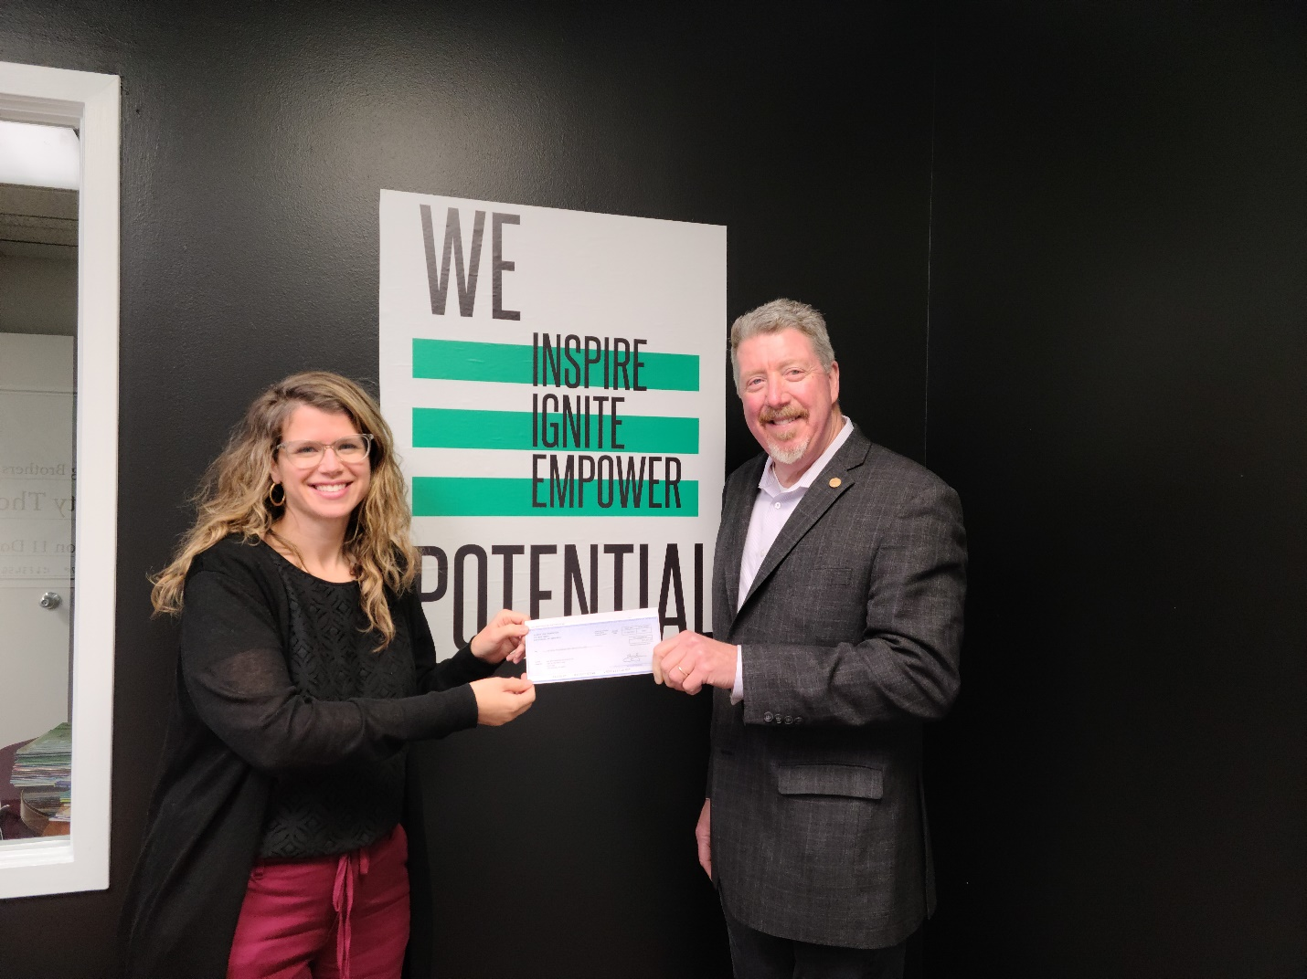

Photo: Alaska USA Foundation donates to Big Brothers Big Sisters of Alaska.

Media Contact
Dan McCue
Executive Director
Alaska USA Foundation
907-786-2807
D.McCue@alaskausa.org

Jessica Small
(she / her / hers)
Account Coordinator
Thompson & Co. Public Relations
Anchorage | Houston
P. 907.561.4488
C. 907.227.2244
thompsonpr.com

