FOR IMMEDIATE RELEASE
May 4, 2021

Alaska USA Hosts Vaccine Clinic for Employees

ANCHORAGE, Alaska — Alaska USA Federal Credit Union, in partnership with the Municipality of Anchorage, hosted a COVID-19 vaccine clinic for employees on Wednesday, April 28. This allowed employees and their families access to the vaccine in a familiar setting, the parking lot of the Alaska USA headquarters. The clinic also provided an opportunity for community members to receive the vaccine on a walk-up basis. More than 55 vaccines were distributed during the eight-hour event.

“Alaska USA Federal Credit Union values its community, its members, and most importantly its employees. As a member of the Anchorage community, we thought we would make it simple for our employees and their families to access the COVID-19 vaccine from the comfort of our parking lot,” said Alaska USA Federal Credit Union President and CEO Geoff Lundfelt. “Since we also provided an opportunity for the community to walk up and obtain the vaccine, it’s just one more way we are partnering with Anchorage to keep our families, co-workers, and community safe.”

More about Alaska USA
Alaska USA Federal Credit Union is a member-owned, not-for-profit financial cooperative with $10.2 billion in assets and more than 700,000 members worldwide. The credit union operates more than 90 branches and service facilities in Alaska, Arizona, California, and Washington State. Alaska USA offers a 24/7 Member Service Center and access to more than 55,000 surcharge-free ATMs worldwide, as well as online and mobile solutions.

Learn more at alaskausa.org.

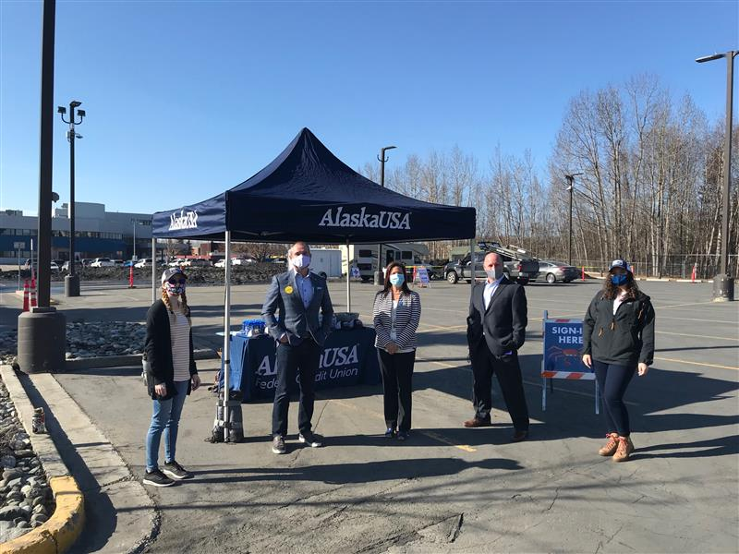
Photo: Alaska USA executives and volunteers are ready for Alaska USA Vaccine Day.

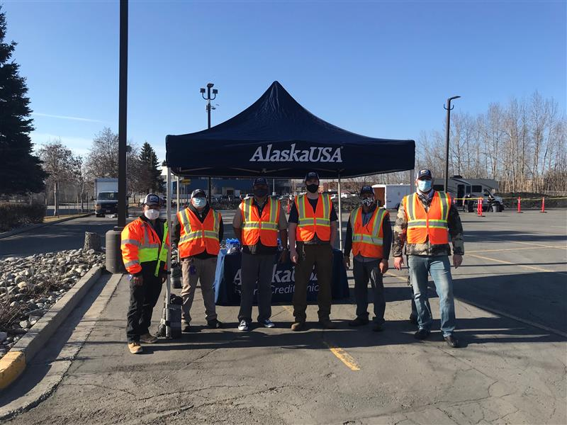
Photo: Alaska USA facilities team made sure that everything was set up perfectly in preparation for Alaska USA Vaccine Day.

###

Media Contact
Dan McCue
Senior Vice President, Corporate Relations
Alaska USA Federal Credit Union
907-786-2807
D.McCue@alaskausa.org

