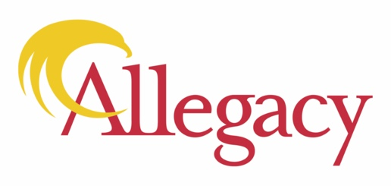
Contact:
Karen Jarvis
336.408.5880
Allegacy Federal Credit Union Donates $10,000 To
Relief Efforts For Weaver Plant Fire

Winston-Salem, N.C. – Allegacy Federal Credit Union announced today a $10,000 donation to help with the recovery and relief efforts in the wake of the Weaver Fertilizer Plant fire that ignited on Monday, resulting in the evacuation of an estimated 6,000 people and closed businesses in a one-mile radius of the fire.

Allegacy made the $10,000 donation to the American Red Cross for emergency relief efforts to assist the evacuees, many who are sheltering at the Winston-Salem Fairgrounds. Allegacy also delivered a truckload of bottles of water to the Second Harvest Food bank for distribution to first responders and those displaced.

“We are proud to help our community partners deliver much-needed aid to the residents and businesses displaced by the Weaver Plant fire, many of whom are part of our Allegacy family,” said Cathy Pace, Allegacy President and CEO. “It is during uncertain and scary times as these that we appreciate the way our community of Winston-Salem comes together to support one another. We encourage organizations and individuals to look for ways to lend a hand by making financial or in-kind donations and volunteering.”
There are several ways other businesses and community members can donate.
- Red Cross - accepting financial donations online, by text, by mail, or phone here. You may designate your donation for emergency relief to assist the response efforts.
- Salvation Army - on standby to serve meals, provide beverages for first responders and displaced persons. Direct donations can be made here.
- Second Harvest Food Bank - Donate funds directly here or deliver bottled water, which is in high demand, to 3655 Reed Street, Winston-Salem, NC 27107
About Allegacy
For 55 years, Allegacy has helped its members, employees and the communities it serves be their best by helping people make smart financial choices. By doing right, Allegacy has become one of the largest credit unions in North Carolina serving over 166,000 members worldwide with $2 billion in assets and over $1.6 billion in assets under management in its financial planning group. With roots in Winston-Salem, Allegacy has 16 locations and nine high school student-run credit unions. Allegacy offers personal and business financial services to help a broad membership base including the employees, retirees and families of over 1,800 companies throughout the country. To learn more, visit Allegacy.org.

