Allied Federal Credit Union
200 SE Green Oaks Boulevard
Arlington, TX 76018

FOR IMMEDIATE RELEASE For More Information, Contact:
March 4, 2022 Sarah Ramos (817.856.4444)
or smramos@afcumail.com

Allied FCU Staff Donate $340 to Arlington’s Care and Share Program, Pay Water Bills For Those In Need

Arlington, TX (March 2, 2022) - Allied Federal Credit Union staff paid $340 worth of water bills for financially struggling Arlington residents as part of the city’s Care and Share Program. Arlington Care and Share uses private donations to pay water bills for those in need and has helped hundreds of families to date. The $340 donation came from Allied FCU’s Casual for a Cause program.

Casual for a Cause lets Allied FCU employees pay to dress casually at work, and money raised goes toward a different local cause each month selected by an employee based committee. They chose Care and Share for February because it allowed them to serve community members hit hardest financially during the recent economic upheaval.

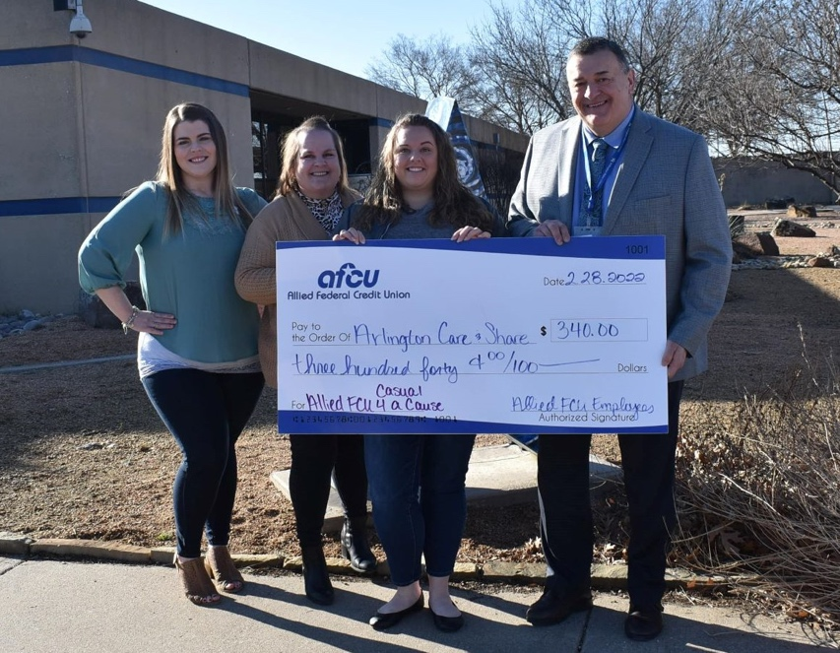
"It saddens me to think there are people living in our city who don't have the basic necessity of running water in their homes, because they've fallen on hard financial times and can't afford to pay their water bills," said Sarah Ramos, Allied Credit Union's AVP of Experience. "We don't want that happening to our members or anyone else living in our community."
About Allied Federal Credit Union:
Allied is headquartered in Arlington, Texas and provides a wide range of services including savings and checking accounts, lending programs and digital/convenience services. Membership is open to anyone who lives, works, worships or attends school in Arlington, Mansfield, Pantego, and Dalworthington Gardens. To open an account or to inquire about the range of products and services available, please call 817.856.4444 or visit https://www.alliedfcu.com/

###

