**Allied Federal Credit Union**

200 SE Green Oaks Boulevard Arlington, TX 76018

**FOR IMMEDIATE RELEASE**

October 12, 2021

*For More Information, Contact:*

Sarah Ramos (817.856.4444) or [smramos@afcumail.com](mailto:smramos@afcumail.com)

page1image64700608

**Allied Federal Credit Union Staff Dress Casual for the NEX Cause**

Employees raise $290 to help provide positive male role models in the Arlington/Mansfield community

Arlington, TX. (October 12, 2021)- AlliedFCU's staff is committed to helping the community in which they serve. Through their Casual for a Cause initiative, employees are invited to pay to dress casually during the month to support organizations within these communities. In September Allied FCU raised and donated $290 towards the NEX Foundation.

“We recognized the need for consistent, positive role models, in the lives of young men, many of which, are being raised in single-parent households. NEX provides personalized support for young men between the ages of 16-20 to help build stronger families, and communities,” said NEX founder Robert Walsh. “We support the next generation of leaders.”

“We believe in programs like NEX that work with the youth in our community and help to develop young leaders,” said Tonia Clark, Allied CEO.

Community involvement has always been in Allied’s DNA. In fact, Allied likes to tell its members, “We’re not just here for you. We are you.” The credit union’s employees live, work, worship, shop and attend school in the same places their members do. That makes Allied an integral part of the communities they serve.

**About NEX:**

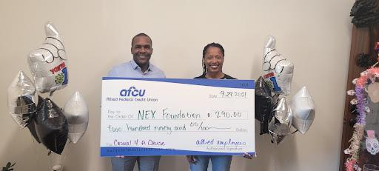

The mission of NEX is to invest in the lives of young men as they make critical decisions and evolve into the NEX phase of their lives. They provide innovative ways to motivate and empower them to overcome obstacles during adolescence into young adulthood.

To learn more about the work NEX is doing to equip young men, visit

[www.nexmetropolitan.org](https://protect-us.mimecast.com/s/-QCQCPN58LfkkVsWI5O1?domain=nexmetropolitan.org)

**About Allied Federal Credit Union:**

Allied is headquartered in Arlington, Texas and provides a wide range of services including savings and checking accounts, investment plans, lending programs and convenience services. Membership is open to anyone who lives, works, worships or attends school in Arlington, Mansfield, Pantego, and Dalworthington Gardens. To open an account or to inquire about the range of products and services available, please call 817.856.4444 or visit [www.alliedfcu.com](https://protect-us.mimecast.com/s/E8xKCQW5RMCyyZuv1t21?domain=alliedfcu.com)

#####

**Colleen Cormier**

**ACCOUNT EXECUTIVE**

[**On The Mark Strategies**](https://protect-us.mimecast.com/s/KAq9CG6QE0fQQXupsVuz?domain=markarnold.com/)

**SPEAKING   BRANDING   PLANNING**

[BLOG](https://protect-us.mimecast.com/s/MpfvCJ67RBfDDMsLGJGz?domain=markarnold.com/)  l  [LINKEDIN](https://protect-us.mimecast.com/s/BfNJCKr5RDtGGphpk4j_?domain=linkedin.com/)

[**Subscribe to quick tips to help your credit union or community bank.**](https://protect-us.mimecast.com/s/nH5UCL95REtZZ8Ug3y5L?domain=markarnold99159.activehosted.com)