**FOR IMMEDIATE RELEASE**

April 23, 2021

**Alltru Receives a CUNA Diamond Award For Rebranding**

*CUNA Councils presented Alltru Credit Union with a Diamond Award during its annual competition, recognizing creative excellence and outstanding results in credit union marketing.*

**ST. LOUIS, MO (April 23)** - In the credit union industry, the [CUNA Marketing & Business Development Diamond Awards](https://www.cunacouncils.org/content/cuna/councils/awards---scholarships/awards-programs/cuna-marketing---business-development-council-awards-programs/cuna-marketing-diamond-awards.html) represent the pinnacle of credit union marketing initiatives. Ranging from 35 different categories, the Diamond Awards highlight outstanding marketing and business development achievements in the credit union industry, and credit unions from all over the country submit numerous campaigns, logos, rebrands, and multi-media entries in hopes of being selected for one of these prestigious industry awards.

[Alltru Credit Union](https://alltrucu.org/) received a 2021 CUNA Diamond Award in the category *Re-Brand/New Corporate Identity*. In November of 2020, Alltru Credit Union completed a rebranding and changed their name from the former 1st Financial Federal Credit Union. Alltru launched a brand-new website, transformed the branches, and participated in a variety of marketing campaigns including but not limited to billboards, TV commercials, social media teasers, and extensive in-branch promotion.

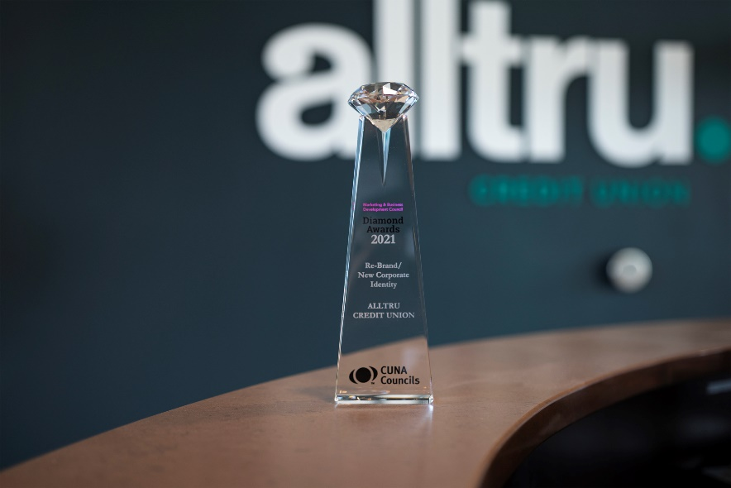

“Credit unions that receive these awards should be extremely proud of their accomplishments and know that their work represents the very best examples of creativity, innovation, relevance and execution,” said Amy McGraw, diamond awards chair and VP marketing/chief experience officer at Tropical Financial CU.

With 1,278 entries submitted and a select number of award recipients, CUNA celebrated creative excellence and outstanding results in credit union marketing with a series of daily virtual award ceremonies.

The complete list of winners can be found [here](http://www.adque.com/CUNA/2021/CUNA_Menu.html).

###

**About Alltru Credit Union**

Established in 1968, Alltru Credit Union is a full-service community development financial cooperative (CDFI) whose mission is to improve the financial well-being of its members. With assets exceeding $290 million, Alltru offers a full line of dependable financial products and services and serves more than 35,000 people throughout St. Louis City, St. Louis County, and St. Charles County.

**Media Contact:**

Laura Woods – VP of Marketing and Community Presence; (636) 916-8303; lwoods@alltrucu.org