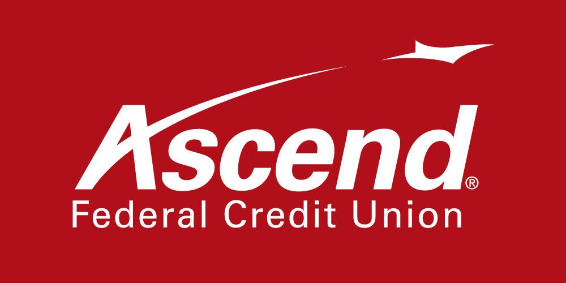

For more information:

Colby Wilson
Corporate Communications Lead
800-342-3086 ext. 1117
COWilson@ascend.org

Ascend Federal Credit Union Contributes $12,293 to Susan G. Komen Breast Cancer Foundation

TULLAHOMA, Tenn. – Dec. 7, 2021 – Ascend Federal Credit Union today announced it has donated $12,923 to the Tennessee chapter of the Susan G. Komen Breast Cancer Foundation. The contribution includes $10,000 from the credit union and $2,923 from Ascend employees. The money will help fund local breast cancer detection and support projects for those with critical needs, with the goal of eliminating barriers to lifesaving services.

Employee donations were raised via an annual casual dress program called Passionately Pink for a Cure, in which Ascend employees donate a minimum of $5 every Friday and Saturday in October to wear blue jeans, breast cancer awareness T-shirts and Susan G. Komen pins to work. Including the $2,923 raised this year, Ascend employees have raised $16,178 for Susan G. Komen since 2018.

“We extend gratitude once again to Ascend for another generous donation to Susan G. Komen,” said Tim Newman, Susan G. Komen Tennessee State executive director. “This money will mean so much to the many people who are trying to make financial ends meet as they undergo treatment against cancer. The financial demands of pain medication, chemotherapy and other needed services can be overwhelming. This thoughtful gift will help continue the fight.”

“We are extremely proud of our 18-year partnership with Komen,” said Caren Gabriel, Ascend president and CEO. “Our employees continue to show a giving spirit and demonstrate how committed they are to helping Middle Tennesseans in need. Our hope is that this donation will assist those battling breast cancer to access the best treatment and healthcare available.”

Susan G. Komen, the world’s leading breast cancer organization, is focused on saving lives and creating a world without breast cancer. Since 1997, Susan G. Komen and its supporters in the state of Tennessee have contributed more than $12.1 million to support breast cancer research in the state and across the U.S. Since 1982, Komen has awarded $19.1 million for 56 research grants to organizations in Tennessee.

About Ascend Federal Credit Union
With more than 233,564 members and more than $3.5 billion in assets, Ascend Federal Credit Union is the largest credit union in Middle Tennessee and one of the largest federally chartered credit unions in the United States. Based in Tullahoma, Tenn., the member-owned financial institution offers banking, loan, retirement and investment services from its 27 branches, more than 55,000 free ATMs worldwide, online banking portal and mobile app. The credit union’s mission is to serve by offering financial literacy education and giving back to its community in a variety of ways — including being the naming rights sponsor of Ascend Amphitheater, downtown Nashville’s premier open-air live music venue at Metro Riverfront Park. Ascend is federally insured by the National Credit Union Administration. For more information, visit ascend.org.

###

