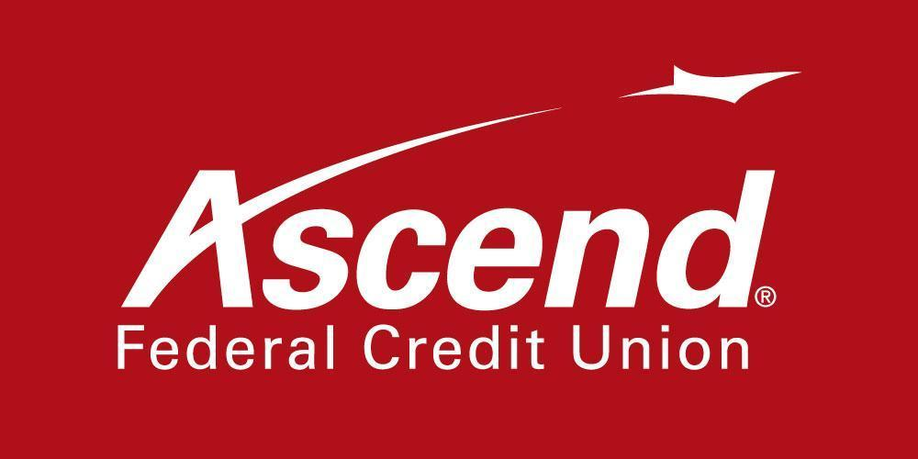

For more information:

Lisa Hayes
Vice President of Marketing
800-342-3086 ext.1352
lhayes@ascend.org

Ascend Federal Credit Union Once Again Wins Best Credit Union in Rutherford County Main Street Awards

TULLAHOMA, Tenn. – Aug. 4, 2021 – Ascend Federal Credit Union, the largest credit union in Middle Tennessee, has been named Best Credit Union in the 2021 Rutherford County Main Street Awards sponsored by the Murfreesboro Post. This is the fourth year in a row Ascend has won Best Credit Union category. Ascend was also one of three finalists for Best Bank and Best Mortgage Lender.

“We are honored to be recognized once again for this award by the Murfreesboro Post readers,” said Ascend President and CEO Caren Gabriel. “Ascend strives to make a difference in the communities we serve and the lives of the members who reside there. This award is a direct reflection of the hard work of our employees, and I cannot thank them enough for their dedication.”

Winners were selected by Murfreesboro Post readers, who cast more than 102,000 votes this year for their favorite local businesses, breaking all previous voting records. This was the fifth year the Murfreesboro Post has held the awards for Rutherford County.

The awards ceremony was streamed live on Murfreesboro Post’s Facebook page on July 22. The ceremony is traditionally held in person, but was moved online for the second consecutive year due to COVID-19. To view the awards presentation video, visit murfreesboropost.com.

About Ascend Federal Credit Union
With more than 233,564 members and more than $3.2 billion in assets, Ascend Federal Credit Union is the largest credit union in Middle Tennessee and one of the largest federally chartered credit unions in the United States. Based in Tullahoma, Tenn., the member-owned financial institution offers banking, loan, retirement and investment services from its 28 branches, more than 55,000 free ATMs worldwide, online banking portal and mobile app. The credit union’s mission is to serve by offering financial literacy education and giving back to its community in a variety of ways — including being the naming rights sponsor of Ascend Amphitheater, downtown Nashville’s premier open-air live music venue at Metro Riverfront Park. Ascend is federally insured by the National Credit Union Administration. For more information, visit ascend.org.

###

