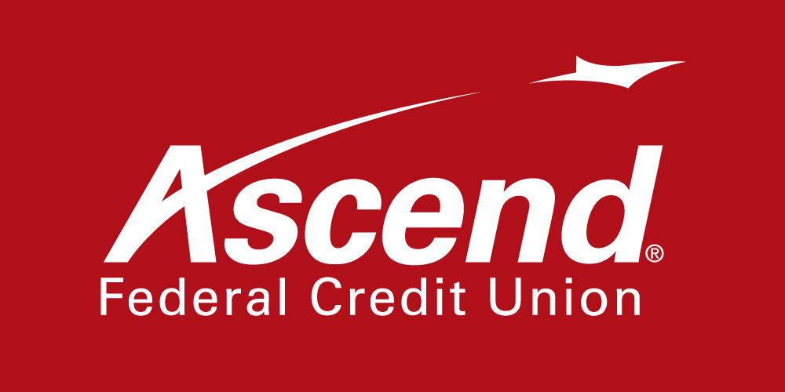

For more information:

Colby Wilson
Corporate Communications Lead
800-342-3086 ext. 1117
COWilson@ascend.org

Ascend Federal Credit Union Paying $7 Million to Members

Tullahoma-based company one of the nation’s
few credit unions to offer a member return

TULLAHOMA, Tenn. – Dec. 10, 2021 – Ascend Federal Credit Union, the largest credit union in Middle Tennessee, announced today that it will return $7 million to members in the form of bonus dividend payments, loan interest refunds and reward payments for loyal debit card use. With the addition of this year’s return, Ascend’s volunteer, unpaid board of directors has approved giving a total disbursement of more than $99 million to the credit union’s members since 2004.

“At Ascend, our members are owners and we fulfill our non-profit mission by returning to them a significant portion the proceeds generated by our well-run credit union,” said Caren Gabriel, Ascend president and CEO. “I also can’t think of a better way to culminate our 70th anniversary year by making the holidays brighter for our members and showing our gratitude for being entrusted with serving their financial needs.”

Gabriel said the member return is never guaranteed, but it is a goal of Ascend’s board to distribute it every year. Thanks to growing membership and use of the credit union, as well as prudent management, members have received a return every year for the last 17 years.

The credit union examines its financial performance each year to identify how the return will be calculated and what amount will be given. Generally, the more checking/debit or savings activity someone has with Ascend, the greater their bonus payment, and the more loans they have, the greater their loan interest refund. In order for a loan to receive an interest refund, it must not be delinquent.

The 2021 return will appear on members’ December statements.

About Ascend Federal Credit Union
With more than 233,564 members and more than $3.5 billion in assets, Ascend Federal Credit Union is the largest credit union in Middle Tennessee and one of the largest federally chartered credit unions in the United States. Based in Tullahoma, Tenn., the member-owned financial institution offers banking, loan, retirement and investment services from its 27 branches, more than 55,000 free ATMs worldwide, online banking portal and mobile app. The credit union’s mission is to serve by offering financial literacy education and giving back to its community in a variety of ways — including being the naming rights sponsor of Ascend Amphitheater, downtown Nashville’s premier open-air live music venue at Metro Riverfront Park. Ascend is federally insured by the National Credit Union Administration. For more information, visit ascend.org.

###

