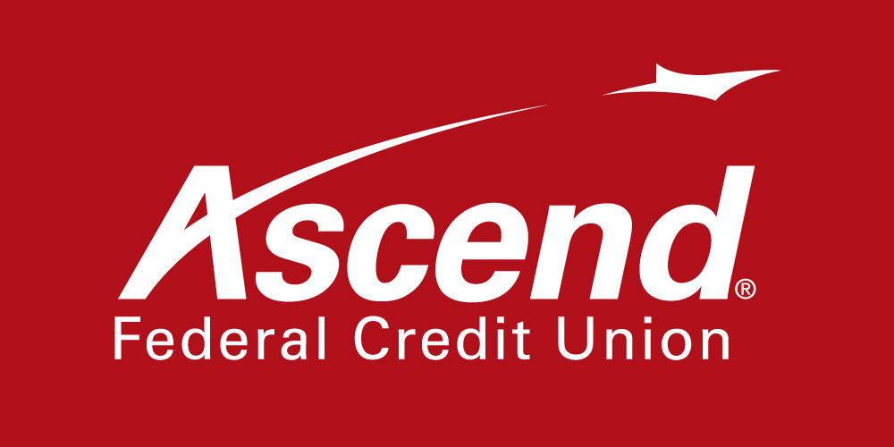

For more information:

Colby Wilson
Corporate Communications Lead
800-342-3086 ext. 1117
COWilson@ascend.org

Ascend Federal Credit Union Donates $10,000 to Support Health Care Services for Working, Uninsured Patients

Contribution to Partners for Healing helps the non-profit provide free primary health care services to people in southern Middle Tennessee

TULLAHOMA, Tenn. – Jan. 11, 2021 – Ascend Federal Credit Union announced today that it has donated $10,000 to Partners for Healing, a leading non-profit organization headquartered in Tullahoma that provides free primary health care services to the working uninsured. The donation will help Partners for Healing fulfill its mission of serving the health care needs of individuals in Coffee, Franklin and Moore counties. Ascend has supported Partners for Healing since 2013.

“Once again, we are pleased to assist our friends at Partners for Healing,” said Caren Gabriel, Ascend president and CEO. “Without aid from Partners for Healing, Middle Tennesseans who need the most help might otherwise go without treatment because they can’t afford it. This organization is making a significant impact in our community.”

Due to the increased need for mental health services during the COVID-19 pandemic, the number of mental health patients helped by Partners for Healing in 2021 has increased 68% from last year. Through December of 2021, Partners for Healing had provided more than 2,500 primary care appointments to 427 patients and dispensed 5,400 free 30-day prescriptions.

“COVID-19 has continued to affect our patients in the past year,” said Lynn Brumfield, executive director of Partners for Healing. “Mental health has always been a necessity in our patient population and the pandemic has only increased that need. Ascend’s generous donation allows us to continue to serve our patients and help them with both their physical and mental health needs.”

The donation comes from Ascend’s Charitable Donation Account (CDA), which was established in November 2017 by its board of directors. The CDA allows Ascend to generate revenue from investments to support various charitable endeavors.

About Partners for Healing
Partners for Healing is a 501(c)3 free primary medical clinic that was established in 2001 in Tullahoma. The organization provides care for those who live or work in Franklin, Coffee and Moore counties. To qualify for services, applicants must have a total household income of less than 250% of the Federal Poverty Guidelines and at least one member of the household must work a minimum of 20 hours each week. Partners for Healing services include on-site lab, free 30-day prescriptions for many drugs, ultrasounds, prescription assistance for medications, mental health counseling, quarterly mammogram screenings and a referral system to specialists, and physicians and hospitals who provide care to its patients at a discounted rate. For more information, visit partnersforhealing.org.

About Ascend Federal Credit Union
With more than 233,564 members and more than $3.5 billion in assets, Ascend Federal Credit Union is the largest credit union in Middle Tennessee and one of the largest federally chartered credit unions in the United States. Based in Tullahoma, Tenn., the member-owned financial institution offers banking, loan, retirement and investment services from its 27 branches, more than 55,000 free ATMs worldwide, online banking portal and mobile app. The credit union’s mission is to serve by offering financial literacy education and giving back to its community in a variety of ways — including being the naming rights sponsor of Ascend Amphitheater, downtown Nashville’s premier open-air live music venue at Metro Riverfront Park. Ascend is federally insured by the National Credit Union Administration. For more information, visit ascend.org.

###

