**DRAFT**

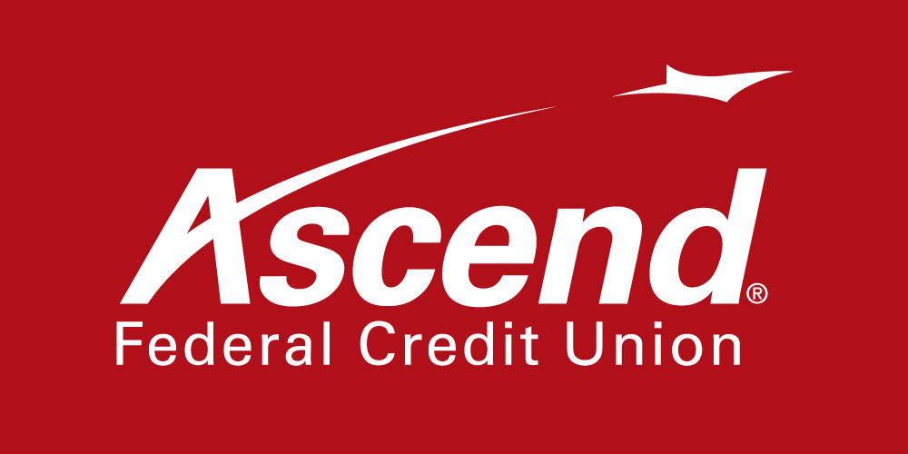

For more information:

# Colby Wilson

Corporate Communications Lead

800-342-3086 ext. 1117

[COWilson@ascend.org](mailto:COWilson@ascend.org)

**DONATIONS BY ASCEND FEDERAL CREDIT UNION AND ITS MEMBERS PROVIDES MORE THAN 300,940 MEALS TO MIDDLE TENNESSEANS**

**NASHVILLE, Tenn., Dec. XX, 2021** - Ascend Federal Credit Union is donating $70,000 to Second Harvest Food Bank of Middle Tennessee to help individuals and families have access to food this holiday season. Credit union employees and members also contributed an additional $3,235. In total, the donations will pay for more than 300,940 meals for Middle Tennesseans.

Ascend’s members were encouraged to make donations to Second Harvest via a special link provided by the credit union during November. The credit union decided to go the extra mile and add $70,000, increasing the overall donation to $73,235.

“The $70,000 amount is notable as Ascend celebrates its 70th anniversary this year,” said Ascend President and CEO Caren Gabriel. “Second Harvest continues to do important work in our community and our members once again led the way, contributing a significant amount to this donation. The large number of people fed by this caring organization will make a substantial impact in Middle Tennessee.”

“This generous donation from our partners at Ascend Federal Credit Union is so important during this holiday season,” said Nancy Keil, president and CEO of Second Harvest Food Bank of Middle Tennessee. “The demand for our services continues to remain high, and there are many families facing hunger that will be fed and given hope with this contribution.”

Ascend employees also held a corporate-wide food drive, collecting a credit-union wide fund-raising total of 8,846 items to contribute to Second Harvest Food Bank.

**About Ascend Federal Credit Union**

 With more than 233,564 members and more than $3.5 billion in assets, Ascend Federal Credit Union is the largest credit union in Middle Tennessee and one of the largest federally chartered credit unions in the United States. Based in Tullahoma, Tenn., the member-owned financial institution offers banking, loan, retirement and investment services from its 27 branches, more than 55,000 free ATMs worldwide, online banking portal and mobile app. The credit union’s mission is to serve by offering financial literacy education and giving back to its community in a variety of ways — including being the naming rights sponsor of Ascend Amphitheater, downtown Nashville’s premier open-air live music venue at Metro Riverfront Park. Ascend is federally insured by the National Credit Union Administration. For more information, visit [ascend.org](https://ascend.org/).

###