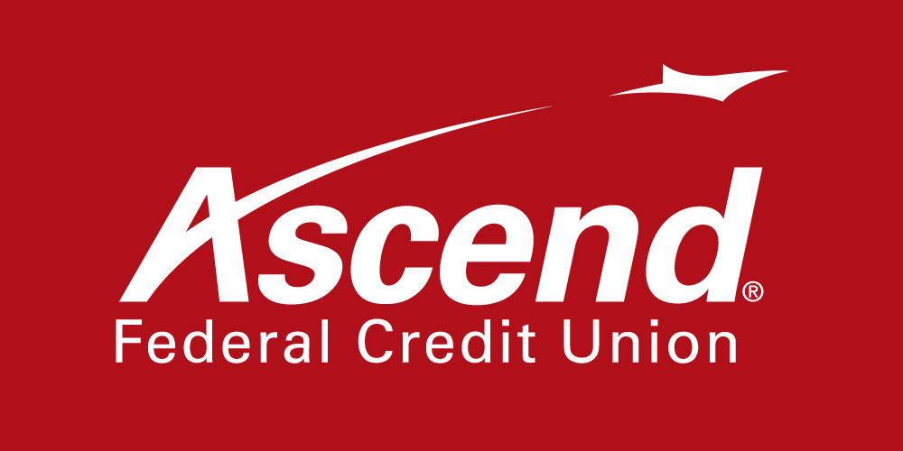

For more information:

Greg Davis
Corporate Communications Lead
800-342-3086 ext.1117
gdavis@ascend.org

Ascend Federal Credit Union Employees Donate 5,279 Food Items to Second Harvest Food Bank of Middle Tennessee

TULLAHOMA, Tenn. – June 30, 2021 – Ascend Federal Credit Union today announced that its employees donated 5,279 food items to the Second Harvest Food Bank of Middle Tennessee. The collection was held in May at Ascend’s corporate office and all of its 28 branch locations.

“It’s important to support Second Harvest throughout the year, as hunger doesn’t discriminate by season, especially this year with many Tennesseans still going through hard times due to the pandemic,” said Ascend President and CEO Caren Gabriel. “I’m so proud of the generosity of our employees, who surpassed our goal by 3,488 items. This small act of kindness will make a big difference to the people in our communities struggling with putting food on the table.”

The Second Harvest food drive collected enough food to donate to 27 different agencies in Middle Tennessee.

Ascend, its employees and its members have been participating in food drives and raising money for Second Harvest since 2018, and they have donated more than 20,000 items during the last four years. The credit union also donated $25,000 to Second Harvest in 2020, which included $2,264 in contributions from members. The total donation paid for more than 190,000 meals for Middle Tennesseans.

About Ascend Federal Credit Union
With more than 231,012 members and more than $3.5 billion in assets, Ascend Federal Credit Union is the largest credit union in Middle Tennessee and one of the largest federally chartered credit unions in the United States. Based in Tullahoma, Tenn., the member-owned financial institution offers banking, loan, retirement and investment services from its 28 branches, more than 55,000 free ATMs worldwide, online banking portal and mobile app. The credit union’s mission is to serve by offering financial literacy education and giving back to its community in a variety of ways — including being the naming rights sponsor of Ascend Amphitheater, downtown Nashville’s premier open-air live music venue at Metro Riverfront Park. Ascend is federally insured by the National Credit Union Administration. For more information, visit ascend.org.

###

