FINAL

BECU Helps Low-Balance Savers Increase Savings by More Than $2 Million with Quick Save, Powered by MX
“Slide to save” tool in mobile app encourages members to put aside small amounts of money regularly
Quick Save resulted in an 18% increase in savings balances and a 26% increase in money movement through mobile transfers
LEHI, Utah— August 18, 2021 — MX, the financial data platform and leader in modern connectivity, today announced it has partnered with BECU, one of the nation’s largest credit unions, to build a mobile app feature Quick Save that encourages BECU members to build savings through frequent, small-amount transfers.
Quick Save was introduced as a pilot in 2020 during the midst of the COVID-19 pandemic to members with low balances in their savings account and offered by BECU as a helpful tool to easily transfer funds to their savings accounts with a “slide to save” module.
BECU partnered with the Financial Health Network (FHN) to measure the pilot of the mobile app experience. FHNs study showed that over the span of five months, during the pilot, BECU saw the following results due to its members' use of Quick Save:

- Over $2 million transferred into members’ savings accounts
- An 18% increase in saving balances for low-balance savers
- A 26% increase in money movement through mobile transfers

BECU and MX will apply the behavioral science learnings of the FHN study (Financial Health Solutions: Targeting Small-Dollar Savings Suggestions to Low-Balance Customers) to future enhancements of Quick Save.

“BECU is continually innovating and leveraging technology to improve our members’ experience and empower them financially. It’s been inspiring to see Quick Save go from a concept to a fully functioning tool that members in this pilot are using to build their savings,” said Liz Wagner, director of digital strategy at BECU. “The combined power of BECU, Financial Health Network, and MX enabled us to create and measure the effectiveness of this experience to meaningfully improve our members' financial health.”

In the credit union spirit of “people helping people,” BECU identified a segment of its membership that seemed to be struggling to build their savings, and the Quick Save mobile app tool is the result—and one more way BECU is helping its members with low balances increase their savings.

"BECU and MX have been aligned partners for years, both resolute in our determination to help strengthen the financial well-being of BECU members and their community," said Nate Gardner, Chief Customer Officer of MX. "Our latest project with BECU has been building their Quick Save feature, yet another example of BECU's wholehearted commitment to financial strength and to provide intelligent and personalized money experiences for the hundreds of thousands of members they serve."

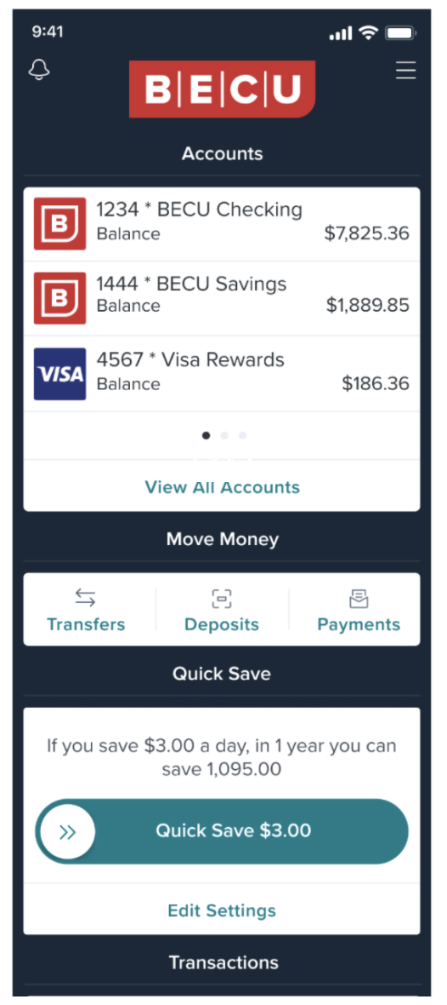

About MX
MX, the financial data platform and leader in modern connectivity, helps organizations everywhere connect to the world’s financial data and turn raw, unstructured data into their most valuable asset to deliver intelligent and personalized money experiences. MX connects more than 16,000 financial institutions and fintechs providing the industry’s most reliable and secure data connectivity network. Additionally, MX powers 85% of digital banking providers, as well as thousands of banks, credit unions, and fintechs, with a combined reach of over 200 million consumers. To learn more, follow us on Twitter @MX or visit www.mx.com.

