**CONTACT INFORMATION:**

Josh Rhoden  
Senior Marketing Specialist  
SRP Federal Credit Union  
803-202-4368  
[jrhoden@srpfcu.org](mailto:jrhoden@srpfcu.org)

**RELEASE DATE:**

Immediate

**SRP Federal Credit Union Supports**

**United Way’s Be A Bunny**

SRP Federal Credit Union was proud to support and participate in United Way of Aiken’s Be A Bunny Campaign for 2021. The Be A Bunny program provides baskets filled with comfort items for seniors in the local community. SRP employees graciously donated 33 baskets filled with everyday necessities and fun treats for United Way of Aiken County to pass out to seniors throughout the community. “SRP is honored to have an exceptionally wonderful team of staff members that participated in this campaign.  Their efforts, volunteerism and donations truly exemplify SRP’s dedication to serve the local community,” stated Grace Helms, Assistant Vice President, Community Development for SRP Federal Credit Union.

SRP Federal Credit Union is headquartered in North Augusta, SC and provides financial services to more than 165,000 members. For more information on SRP Federal Credit Union, visit [www.srpfcu.org](http://www.srpfcu.org).

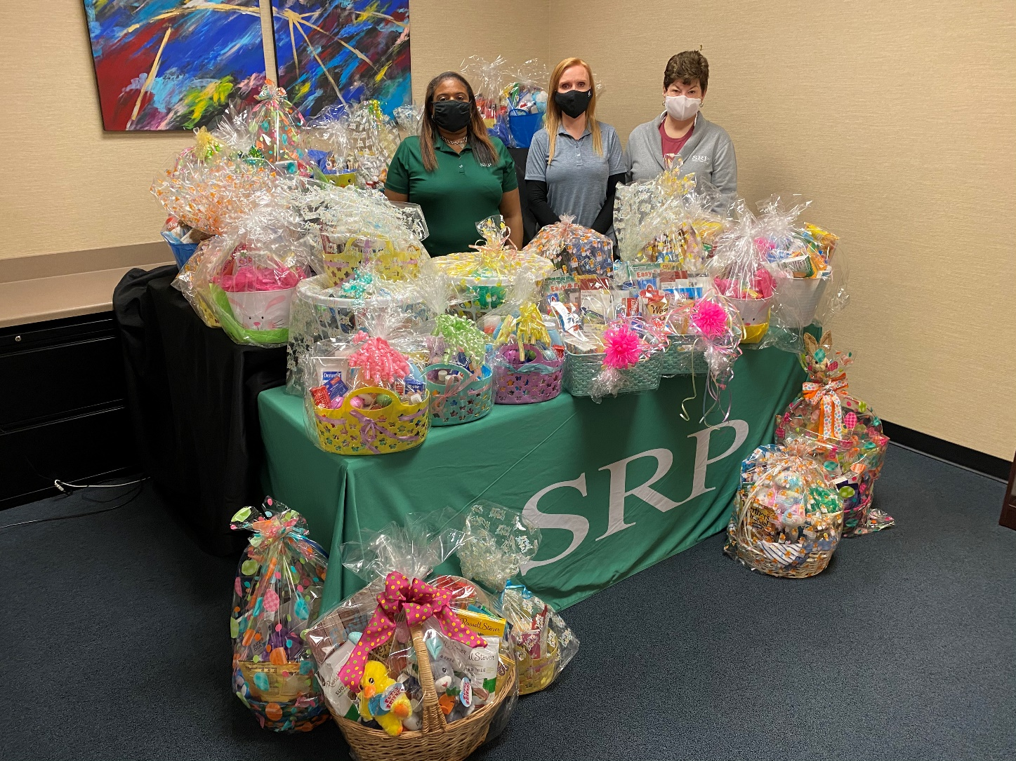

Pictured: SRP Community Development Department: Tawanaca Williams, Grace Helms, Yvonne Meeks