United Federal Credit Union – Press Release
April 13, 2021

Contact: Diana Wake
Phone: (888) 982-1400 ext. 6891
Email: dwake@unitedfcu.com
United Federal Credit Union, 150 Hilltop Road, St. Joseph, Michigan, 49085

United Federal Credit Union Names Bill Golden
Mortgage Advisor in Carson City, Nevada
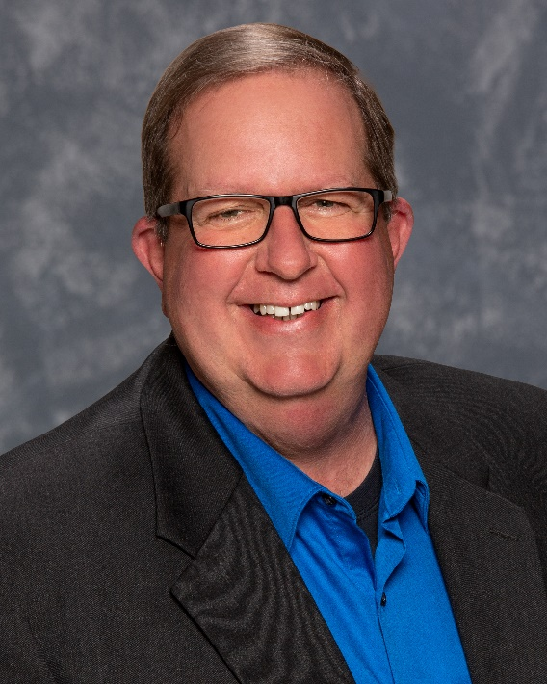
Bill Golden, Mortgage Advisor, Carson City South Branch

CARSON CITY, Nev. – United Federal Credit Union (United) is pleased to announce the appointment of Bill Golden as Mortgage Advisor at the Carson City South Branch at 935 Jacks Valley Road.

Golden will provide quality real estate lending expertise through financial counseling and product awareness to credit union members regarding their real estate financing needs and generate investment quality mortgage loans.

Golden brings more than seven years of mortgage experience to his new role. Most recently, he was a Mortgage Consultant at Greater Nevada Mortgage in Dayton. He pairs his industry knowledge with a passion to help people find the right mortgage option for their new home.

Golden is a Marine Corps Veteran and is actively involved with his local VFW Post. He also volunteers with his church’s food bank and youth programs.
____________
About United
United Federal Credit Union has served its Members since 1949 by helping them to build a sound financial future. United consists of more than 179,000 Member/owners worldwide and manages assets in excess of $3.3 billion. Its corporate offices and main branch are in St. Joseph, Mich., with additional branches in Arkansas, Indiana, Michigan, Nevada, North Carolina, and Ohio. Federally insured by NCUA. Equal opportunity lender. Equal housing lender. For more information visit www.unitedfcu.com

# # #

