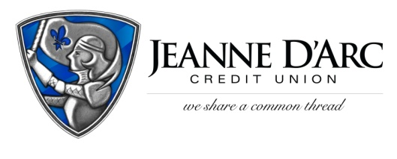

FOR IMMEDIATE RELEASE CONTACT: Robin Lorenzen
June 23, 2021 978-323-3226
PHOTO INCLUDED
Jeanne D’Arc Credit Union Executive Brian Sousa graduates LEADS
LOWELL, MA – Jeanne D’Arc is pleased to announce that Brian Sousa, Senior Vice President and Chief Lending Officer at Jeanne D’Arc Credit Union, recently graduated from Leaders Engaged and Activated to Drive System-wide change (LEADS) as part of the class of 2020-2021.
LEADS is an executive leadership and education experience focused on putting impactful leaders together to put ideas into action. The organization is designed and delivered by Harvard Business School and welcomed 21 leaders from Lowell (along with 55 participants from Haverhill and Lawrence) to participate in a seven-month-long program focused on creating change in the community.
“LEADS is such a powerful program and we’re thrilled that Brian was there to represent Jeanne D’Arc in this year’s Lowell cohort,” said Mark S. Cochran, President & Chief Executive Officer. “Brian’s dedication to the LEADS program is admirable. He gives so much to our communities and his involvement in LEADS will continue to make a difference.”
To participate in the program, the individual must be a strategic thinker and possess a passion for community engagement and collaboration. Brian’s 29 years of experience in the lending and real estate industries made him an ideal candidate for the LEADS program. Brian also serves on several boards including the Board of Directors for the Boys & Girls Club of Greater Lowell, the Senior Advisory Board for the Lowell Community Health Center, and the Advisory Board of Catie’s Closet, Inc.
Brian has long-standing roots in the Lowell community and is a graduate of UMass Lowell.

###
About Jeanne D’Arc Credit Union:
Jeanne D’Arc Credit Union was established in 1912 and is a full-service, community-based financial cooperative. Locally owned by 93,000 members with $1.7 billion in assets, Jeanne D’Arc operates eight full-service branches in Lowell, Dracut (2), Tyngsboro, Chelmsford, Methuen and Westford, Massachusetts and Nashua, New Hampshire; high-school branches at Lowell High, Dracut High, and Nashua High School South; a loan center in Lowell; and a mortgage center in Chelmsford.

Photo cutline: Brian Sousa, Senior Vice President and Chief Lending Officer at Jeanne D’Arc Credit Union graduates with the LEADS class of 2020-2021.

